

Princess Sumaya University for Technology

King Hussein School for Computing Sciences

# Movie Recommendation System

<https://www.kaggle.com/ahmadhamde/ai-project-movie-recommendation-system>

**Prepared By:**

Ahmad Hamde 20180557

Leen Abu Shaar 20170072

**Artificial Intelligence Course Project**

Course Number: 11428

Second Semester - 2020/2021

# Abstract

Our project is concerned with studying the dynamics of movie recommendation algorithms and the different approaches that can be taken to produce output that is inclusive of different people’s interests. A big chunk of the project was concerned with preprocessing, cleaning, and analyzing the targeted data. Three approaches, supervised and unsupervised, were implemented. The first approach being k-means clustering based on genre and a score combining popularity and ratings, showed the least efficacy due to the fact that these inputs are not determining factors for a good recommendation on their own. The second approach improved the efficacy by taking into consideration the words in movie overviews. With Term Frequency Inverse Document Frequency (TF-IDF), recommendations became more focused. Lastly, the third approach showed the most accurate results when considering keywords relative to the movies and cast and crew details. Our three approaches showed promise in a content-based filtering system but were not fully inclusive. A collaborative filtering approach is what is missing, and what we concluded to be a key factor in an efficient recommendation system.

Table of Contents

Chapter 1: Introduction 7

1.1 Problem Definition 8

1.2 Motivation 8

1.3 Project Objectives 9

1.4 Challenges 9

1.4.1 Lack of Data 9

1.4.2 Inaccurate Data 10

1.4.3 New Entry Data 10

1.4.4 Limited Computing Power 10

1.4.5 Maintaining an Up-to-Date System 11

1.4.6 Challenges with Code 11

1.5 Literature Review 13

Chapter 2: Data Description 17

2.1 The Datasets 17

2.2 Attributes and Sample Data 17

2.2.1 TMDB 5000 Movie Dataset 17

2.2.2 The Movies Dataset 20

Chapter 3: Methodology and Results 24

3.1 Data Importing and Merging 24

3.2 Data Preprocessing 27

3.2.1 Preprocessing of Genres 27

3.2.2 Preprocessing of Vote Averages 30

3.3 Data Visualization 32

3.4 Approaches 38

3.4.1 Demographic Filtering to Introduce Recommendation Systems 38

3.4.2 Failed Approach: Self-Organized Maps to Recommend Movies Based on Genre and Score 41

3.4.3 K-Means Clustering to Recommend Movies Based on Genre and Score 42

3.4.4 Term Frequency - Inverse Document Frequency (TF-IDF) to Recommend Movies Based on Overview 54

3.4.5 Term Frequency to Recommend Movies Based on Cast, Crew, Keywords, and Genres 57

Chapter 4: Conclusion 59

References 60

Table of Tables

Table 1: Data Sample from TMDb's “Credits” File 18

Table 2: Data Sample from TMDb's “Movies” File (1) 19

Table 3: Data Sample from TMDb's “Movies” File (2) 19

Table 4: Data Sample from The Movies Dataset “Credits” File 20

Table 5: Data Sample from The Movies Dataset “Keywords” File 21

Table 6: Data Sample from The Movies Dataset “Movies Metadata” File (1) 21

Table 7: Data Sample from The Movies Dataset “Movies Metadata” File (2) 22

Table of Figures

Figure 1: Mismatch in Attribute Data Type on Merging 11

Figure 2: Inaccurate Data in "id" and "popularity" Attributes 12

Figure 3: Genres as a List of Dictionaries 12

Figure 4: Collaborative Filtering vs. Content-Based Filtering 14

Figure 5: TF-IDF Matrix 16

Figure 6: Merging Plan for "TMDb 5000 Movie Dataset" and "The Movies Dataset" 23

Figure 7: Importing of Datasets 24

Figure 8: First Dataset Information 25

Figure 9: Incorrect Data Types in First Dataset 25

Figure 10: Converting the "id" Values to Integers 26

Figure 11: Converting the "popularity" Values to Float Values 26

Figure 12: Setting the Genre Attributes for Movies 28

Figure 13: Sample Data Showing Genre Attributes 29

Figure 14: IMDb's Weighted Rating Former Formula 30

Figure 15: Application of IMDb's Weighted Rating Formula and Resulting Attribute Values 31

Figure 16: Kaggle's Error for Exceeded Memory Allocation 31

Figure 17: Filtering Data to Movies with a Rating Higher than 5.75 31

Figure 18: Bar Plot Showing Count of Genres 32

Figure 19: Histogram of Popularity Scores 33

Figure 20: Histogram of Weighted Average Ratings 34

Figure 21: Histogram of Movie Release Years 35

Figure 22: Box Plot of Popularity Scores 36

Figure 23: Box Plot of Weighted Average Ratings 37

Figure 24: Bar Plot Showing the Ten "Most Popular" Movies 38

Figure 25: Bar Plot Showing the Ten "Highest Rated" Movies 39

Figure 26: Score Value Calculation and Sample Values 40

Figure 27: Scatter Plot Showing SOM Result 41

Figure 28: Importing Methods for k-Means Clustering 42

Figure 29: Elbow Visualizer with Output 43

Figure 30: Implementing k-Means Clustering 44

Figure 31: k-Means Clustering Labels Stored in "cluster" Attribute 45

Figure 32: Movie Posters of Six Movies in Three Different Clusters (Action, Animation, and Comedy) 45

Figure 33: Bar Plot Showing the Count of Movies in Each Cluster 46

Figure 34: Inverse Indexing Variable 47

Figure 35: Recommendation Function (Clustering) 48

Figure 36: Recommendation Function Output with "Ice Age" as Input 49

Figure 37: The Hits and Misses of "Ice Age" Recommendations 50

Figure 38: Recommendation Function Output with "Alice in Wonderland" as Input 51

Figure 39: The Hits and Misses of "Alice in Wonderland" Recommendations 52

Figure 40: "Toy Story" Recommendations 53

# Chapter 1: Introduction

When was the last time you used a recommendation system? Without knowing it, it might have been today. Perhaps you were scrolling through the news feed of your social media account and viewed a suggested post that stopped you from scrolling further. You might have just searched Google for an answer or asked Siri for a song. The gist is: recommendation systems are everywhere.

Recommendation systems have gained their popularity when their impact has shown astonishing results for businesses in particular. This impact included a change in consumer behavior, and the result: an increase in revenue. For instance, Amazon recorded around a 29% increase in revenue upon introducing recommendations. Another company, Netflix, claims that 80% of what users watch was recommended to them. We may conclude that their recommendation system is succeeding at attracting viewers and easing their user experience, and this could in its turn, maintain or increase subscriptions.

There are a variety of ways in which recommendation engines operate, and they sure have developed over time. Starting with a static approach, these engines were based on nothing but a look-up table. With the revolutionary advancements in artificial intelligence, recommendations became far more intelligent. In some cases, not only do they rely on machine learning, but they even incorporate deep learning. An example of this would be Youtube. With a sophisticated architecture, the Youtube recommendation system effectively suggests videos. It is not only trained to suggest videos of high interest but learns the art of recommendation based on different measures regarding user patterns. Therefore, these systems are highly intelligent and have become significant applications of artificial intelligence.

This project introduces a movie recommendation system within a simple interface. The proposed project is machine-learning-based and aims to explore the effectiveness of machine learning in an important application of it.

## 1.1 Problem Definition

The process of finding a new movie to watch may take a long time and be bothersome. A content-based filtering [1] recommendation system would allow a user to choose a movie and would ease the time-consuming process by providing a short list of movie recommendations that are compatible with the user’s choice.

## 1.2 Motivation

Recommendation systems are always evolving. Netflix continues to award individuals for enhancing their existing one. Despite the availability of a movie recommendation system, the ways in which one could be implemented are endless. Therefore, the motivation behind this system is to offer a solution that has been uniquely tweaked and tailored to perform at its best.

## 1.3 Project Objectives

The purpose behind the system is to offer users movie recommendations easily and effectively. With a user’s choice of one movie, his or her interaction remains minimal. Complemented with a simple interface, the user can then benefit from a list of movies similar to the one he or she chose, instead of having to look through hundreds of different movie posters offered by Netflix at once. We want users to consider the system their best buddy on their next movie night.

## 1.4 Challenges

Recommendation systems are widely used in today’s technology, yet these systems face many problems due to their dependency on data. In this section, we explore the issues and challenges that span from the use of recommendation systems in our modern technologies.

### 1.4.1 Lack of Data

One of the biggest problems that content-based filtering systems face is the lack of content. In order to build an accurate system, we need to make sure it has enough data to base its judgement on. Problems arise when data is not enough to build a system or is not as diverse as needed.

### 1.4.2 Inaccurate Data

The most powerful aspect of content-based systems is its high dependency on data. In movies specifically, data such as its ratings and popularity can be subjective. This lack or inaccuracy in data can lead to false judgement in such systems.

### 1.4.3 New Entry Data

When a user adds a movie to the collection, the data needs to include information about the movie such as reviews and popularity measures. Even though such data is available online, newly released movies pose a problem as they do not have any concrete ratings based on user liking, thus making it harder to expand the system’s collection with newly released movies.

### 1.4.4 Limited Computing Power

Since our project is based on Kaggle, we have limited computing power and RAM that can be exceeded when working with bigger datasets. Since our dataset includes almost 41 thousand movies, processing the data might take a toll on the servers, causing the project to crash and reload.

### 1.4.5 Maintaining an Up-to-Date System

In movie recommendation systems, data needs to be updated regularly and automatically as new movies are being released regularly, and newer generations are slowly losing interest in older movies.

Our datasets span to 2017 which is considered outdated, yet they serve the purpose of recommendation to those who are still interested in movies that were released a decade ago.

### 1.4.6 Challenges with Code

The most time-consuming section of this project was data preprocessing as we faced five main challenges:

1. Mismatch in data types.  
   Example: “id” being of type “int64” in one data frame, and of type “object” in another, as shown in Figure 1 below.

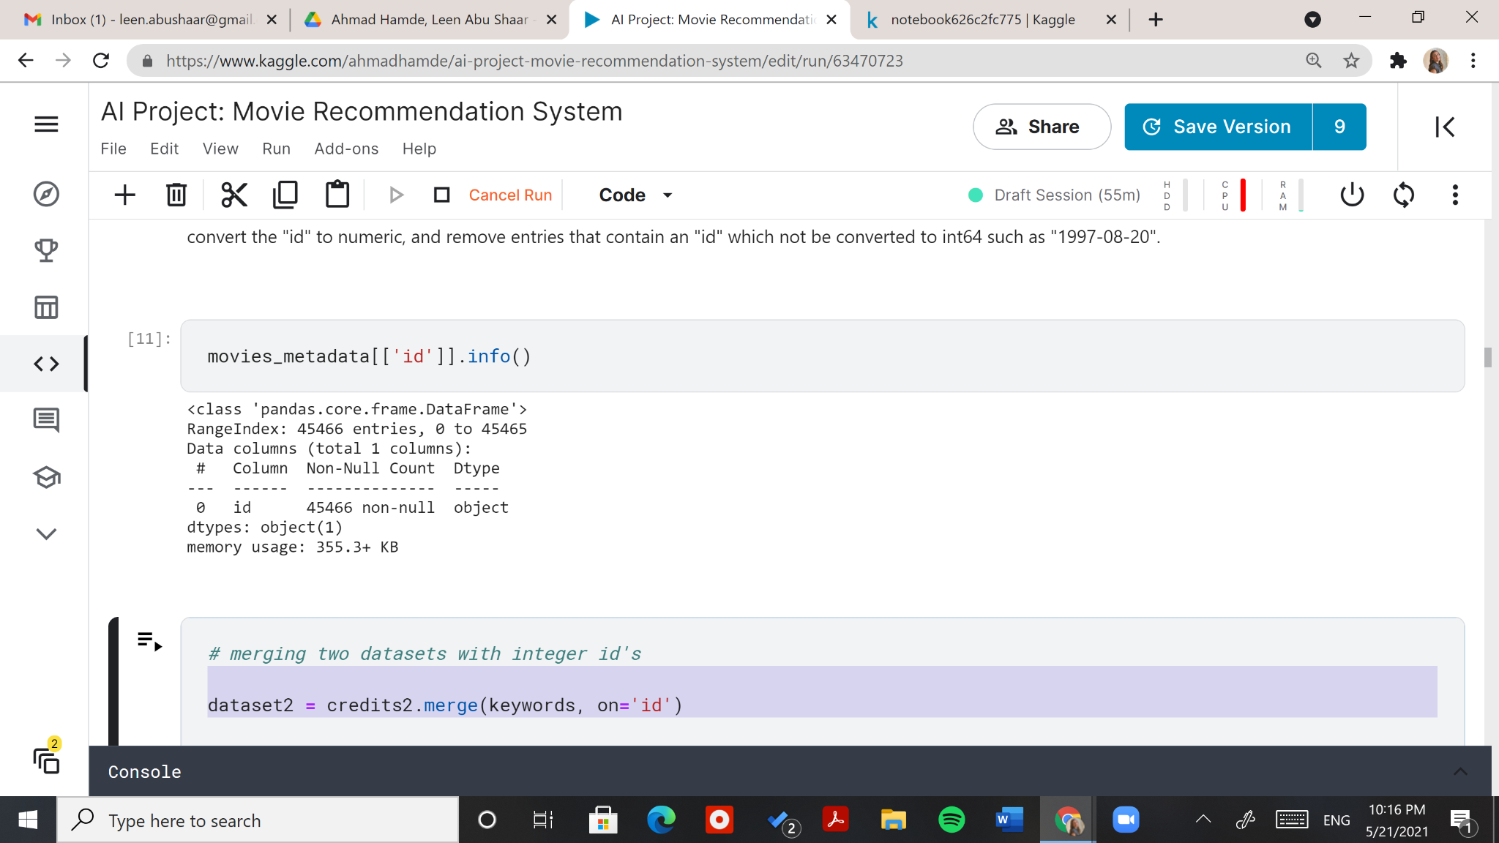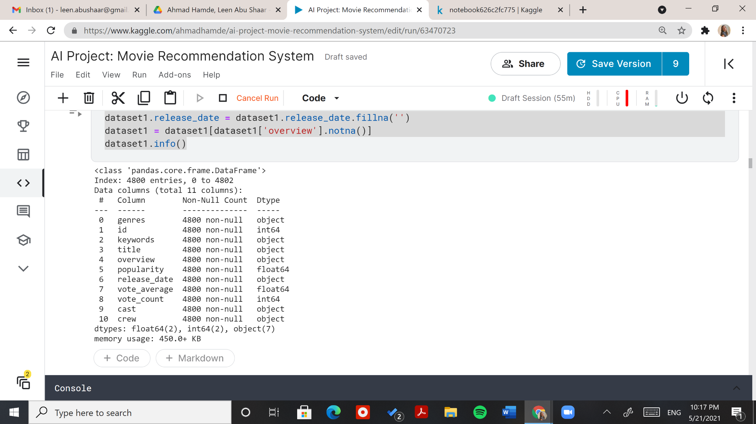

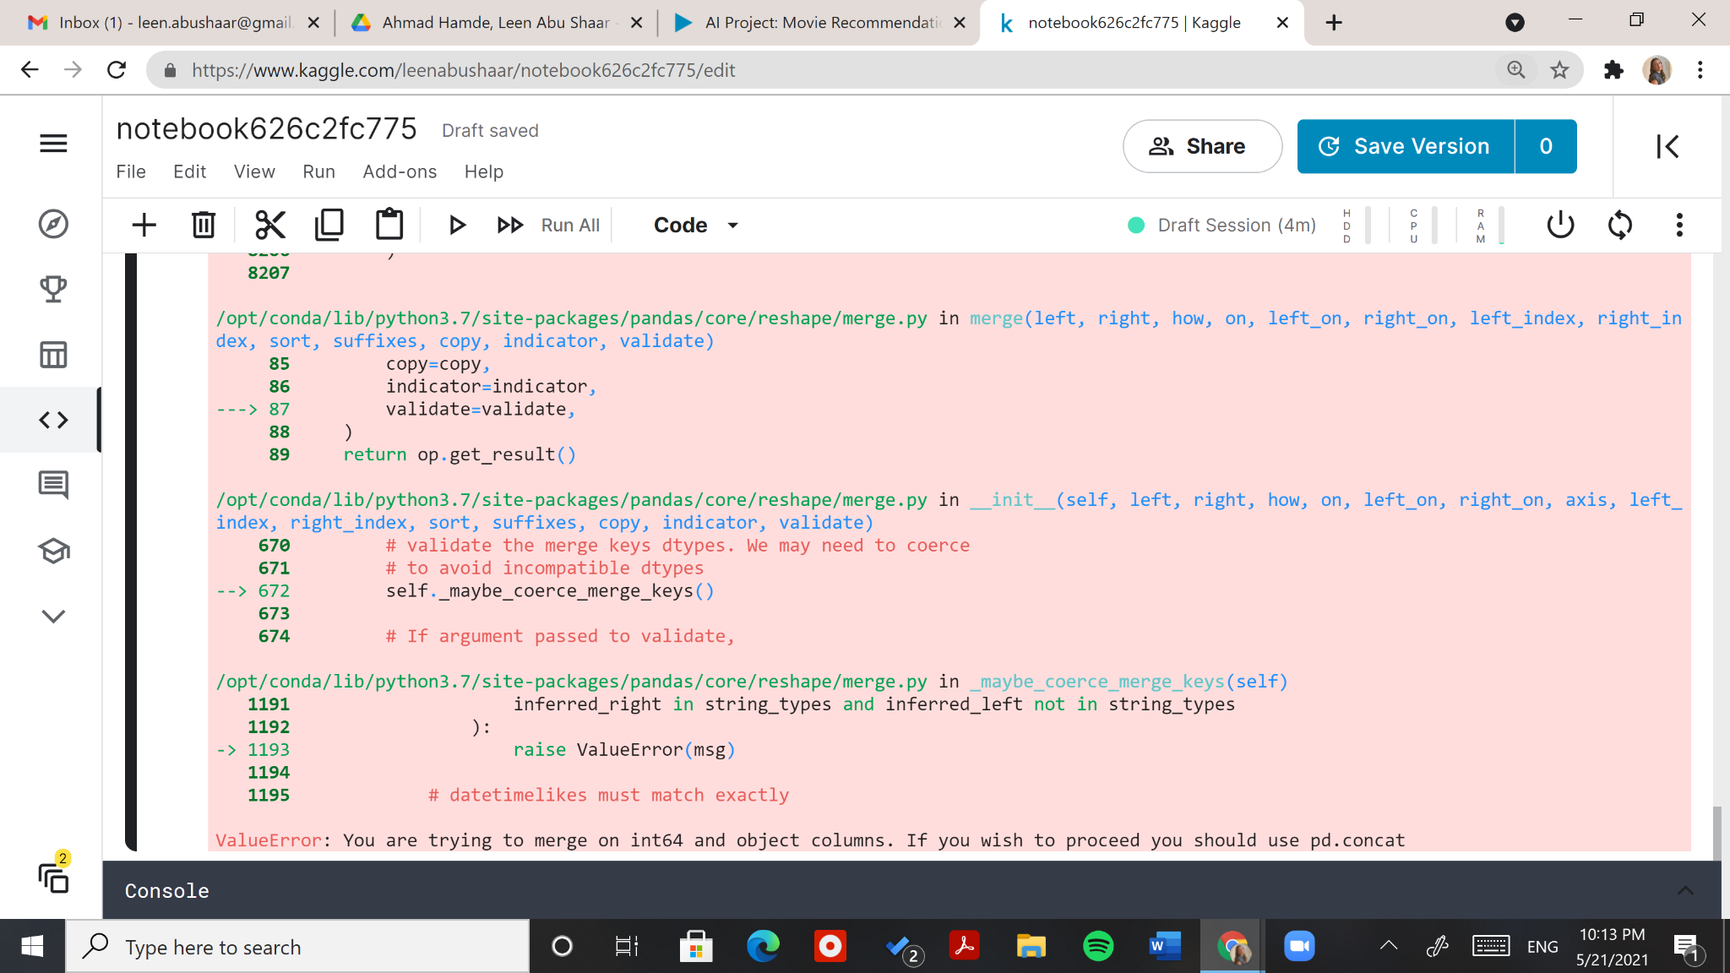

Figure 1: Mismatch in Attribute Data Type on Merging

1. Inaccurate data.

Example: “id” containing a datetime entry, and “popularity” score value containing a movie title, as shown in Figure 2 below.

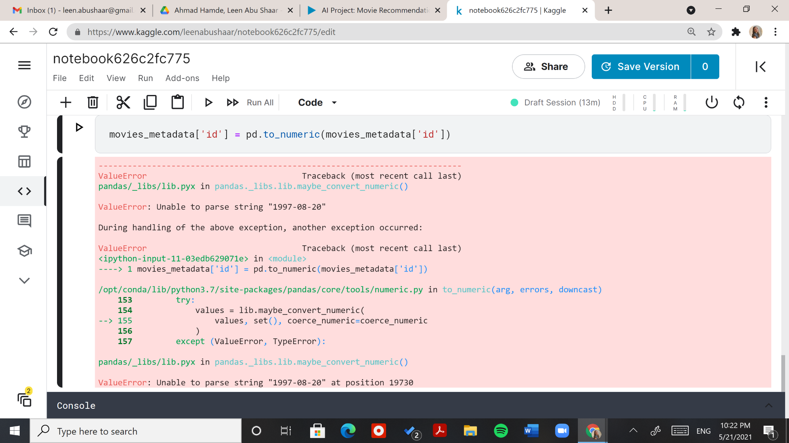

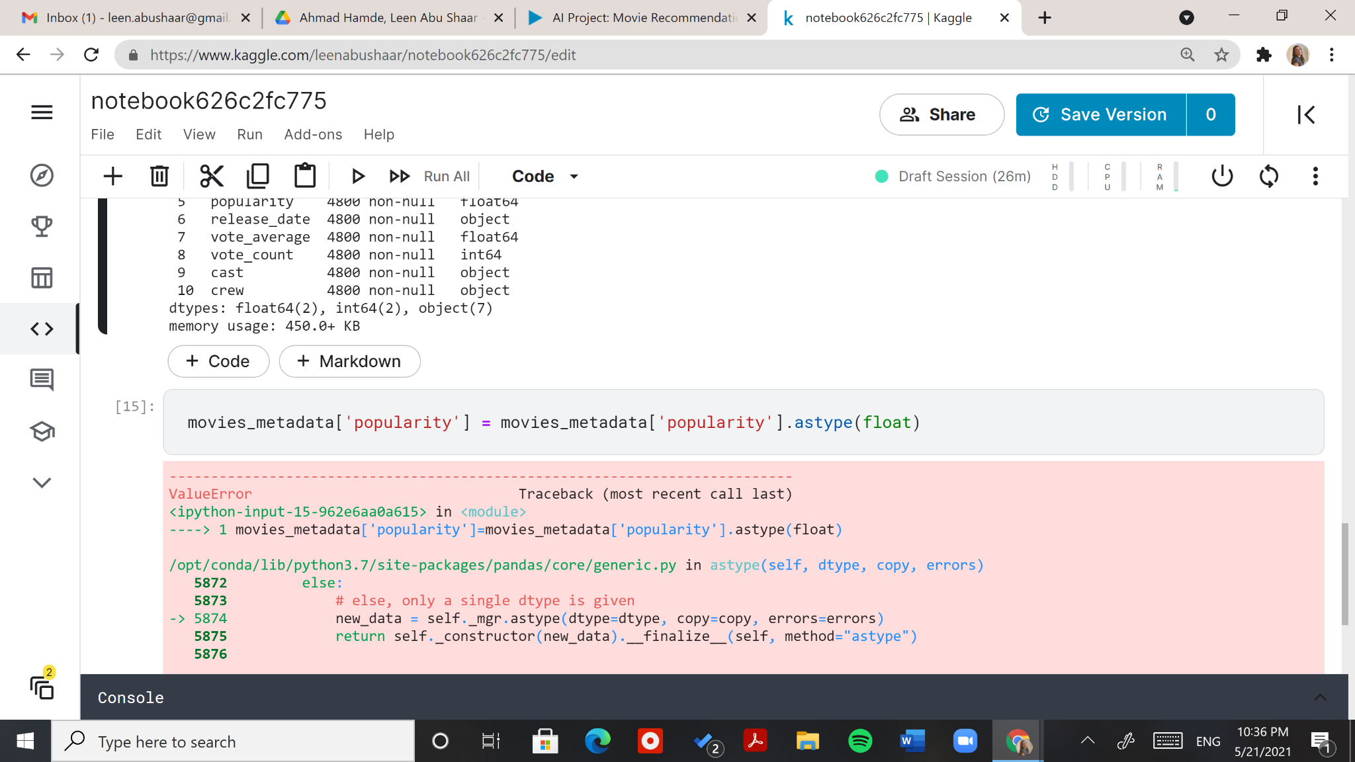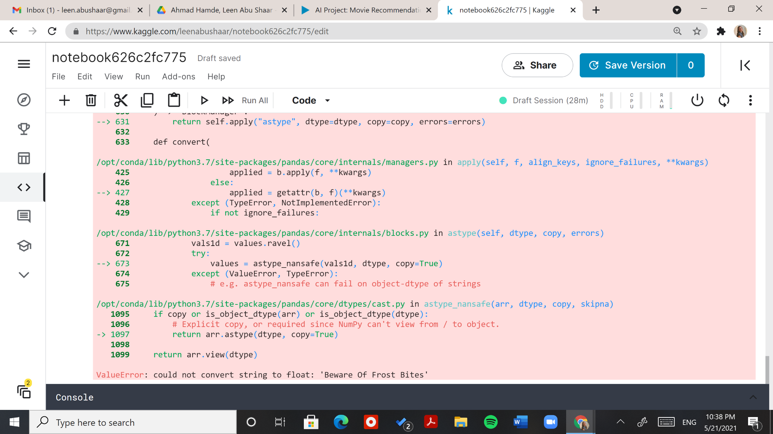

Figure 2: Inaccurate Data in "id" and "popularity" Attributes

1. Null values.

Example: almost 1,000 missing movie overviews: a very important feature that our recommendations depend on.

1. Multivalued data.

Example: extracting important data on “genres” for each movie, which are stored in a list of dictionaries, as shown in Figure 3 below.

Figure 3: Genres as a List of Dictionaries

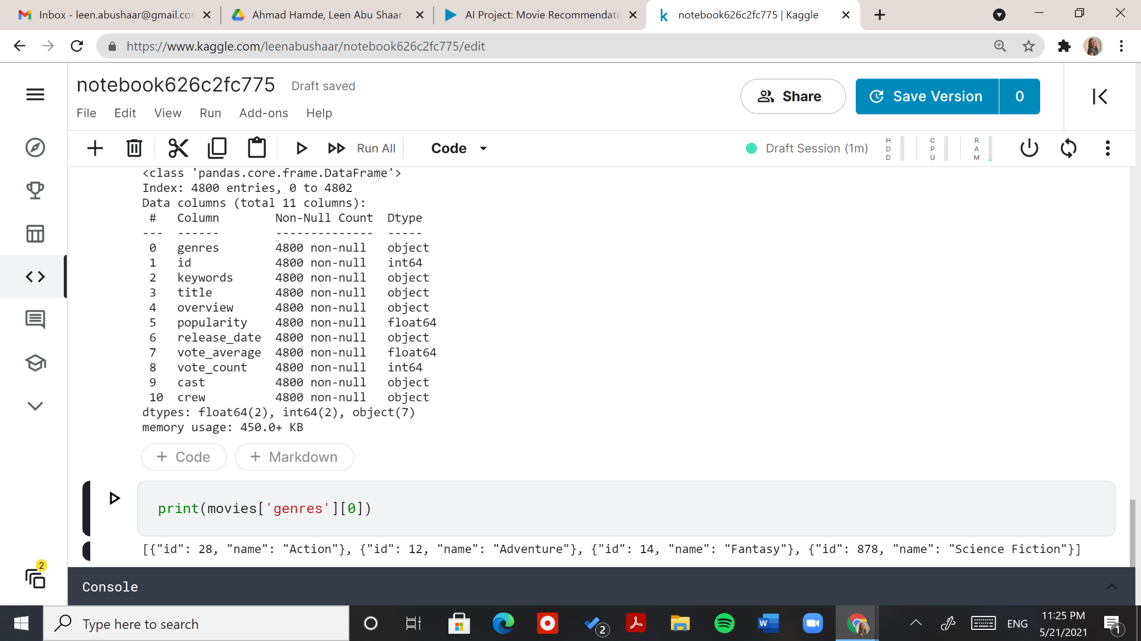

1. Data that is not normalized.

Example: very variant popularity scores, and outliers discussed throughout the document.

The solutions to all five challenges are discussed in Chapter 3: Methodology and Results.

## 1.5 Literature Review

In order to understand recommendation systems, we went over various projects. The star of the show was one done by Ibtesam Ahmed: “Getting Started with a Movie Recommendation System.” [2] It is the one we intend to follow and improve upon.

She starts by explaining the different types of recommendation systems, and the criteria each depends on to make recommendations, including:

1. Demographic Filtering
2. Content-Based Filtering
3. Collaborative Filtering

Figure 4 below shows the differences between content-based and collaborative filtering. The dependency on users in collaborative filtering disqualifies this approach from our system, as authentication and authorization of users is not a feature.

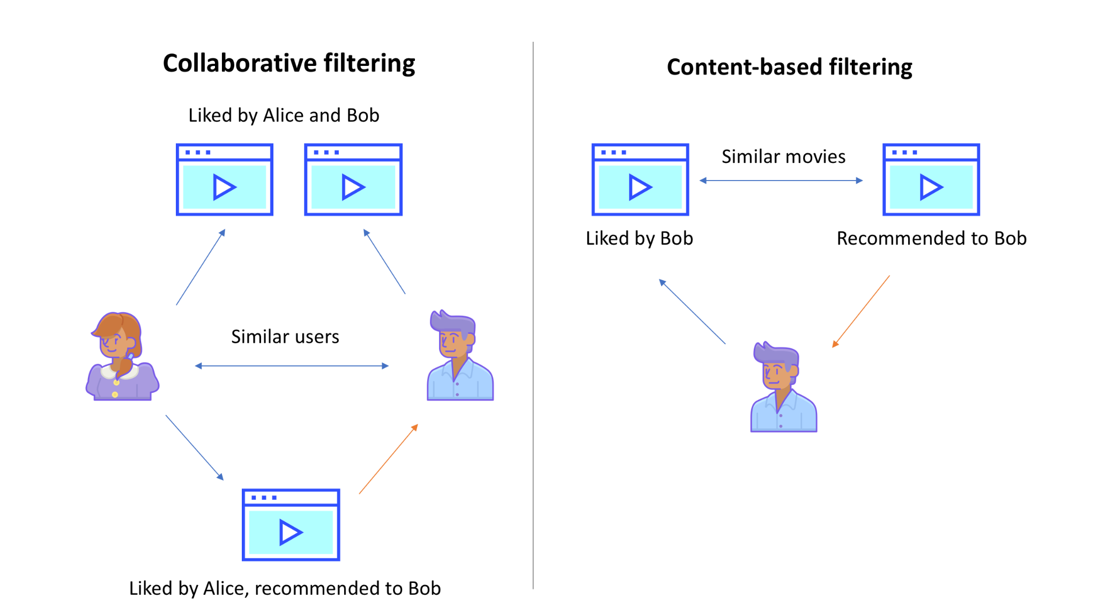[3]

Figure 4: Collaborative Filtering vs. Content-Based Filtering

Ibtesam’s project uses two approaches for demographic filtering - recommending movies based on their:

1. Popularity.
2. Weighted average of user ratings.

These approaches are static. Machine learning is then introduced with two approaches for content-based filtering - recommending movies based on their:

1. Overview.
2. Keywords, genres, cast, and crew.

In our project, we first evaluate the same approaches and experiment with them using different features, machine learning algorithms, and parameters to achieve better results.

We expanded Ibtesam’s dataset which contains about 5,000 movies by combining it with another dataset that contains about 45,000 movies. The goal behind this is not only to provide more movies in the system, but to also yield better recommendation results.

Our addition to her work is data visualization on how normalized the data is. We give explanations throughout this documentation and the Kaggle notebook on the limitations in the datasets used.

For content-based filtering, Ibtesam used Term Frequency-Inverse Document Frequency (TF-IDF). This measure finds the similarity between the words in an input movie’s overview, and the overview of every other movie in the dataset. Figure 5 below shows a matrix with the TF-IDF measures for a group of terms across a collection of documents.

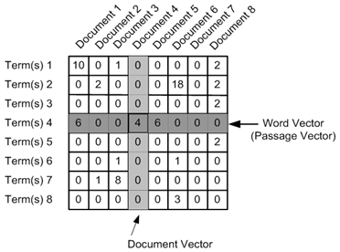[4]

Figure 5: TF-IDF Matrix

The biggest addition to Ibtesam’s work in our project, is an unsupervised learning method. Using k-means clustering, we clustered movies based on both their genres and a score that combines their weighted average rating and popularity.

# Chapter 2: Data Description

Data is at the core of every machine learning project and brainstorming for the right dataset for a movie recommendation system is not a straightforward task. There are many features about a movie that can be taken into consideration when determining the reliability of suggesting it to a user, such as the movie’s popularity, ratings, genre, revenue, release date, plot overview and more.

## 2.1 The Datasets

We merged two datasets for this project. The first is the The Movie Database (TMDb) 5000 Movie Dataset [5]. As the name suggests, the dataset contains descriptive data on about 5000 movies. The Movies Dataset [6] is a bigger dataset with descriptions on about 45,000 movies.

## 2.2 Attributes and Sample Data

### 2.2.1 TMDB 5000 Movie Dataset

TMDB 5000 Movie Dataset contains two relevant files:

1. tmdb_5000_credits.csv:

Table 1 below shows the attributes relevant to our project with their data types, and two rows of sample data.

|  |  |  |  |
| --- | --- | --- | --- |
| movie_id (int64) | title (object) | cast (object) | crew (object) |
| 19995 | Avatar | [{"cast_id": 242, "character": "Jake Sully", "credit_id": "5602a8a7c3a3685532001c9a", "gender": 2, "... | [{"credit_id": "52fe48009251416c750aca23", "department": "Editing", "gender": 0, "id": 1721, "job": ... |
| 285 | Pirates of the Caribbean: At World's End | [{"cast_id": 4, "character": "Captain Jack Sparrow", "credit_id": "52fe4232c3a36847f800b50d", "gende... | [{"credit_id": "52fe4232c3a36847f800b579", "department": "Camera", "gender": 2, "id": 120, "job": "D... |

Table 1: Data Sample from TMDb's “Credits” File

1. tmdb_5000_movies.csv:

Tables 2 and 3 below show the attributes relevant to our project with their data types, and two rows of sample data.

|  |  |  |  |
| --- | --- | --- | --- |
| genres (object) | id (int64) | keywords (object) | overview (object) |
| [{"id": 28, "name": "Action"}, {"id": 12, "name": "Adventure"}, {"id": 14, "name": "Fantasy"}, {"id"... | 19995 | [{"id": 1463, "name": "culture clash"}, {"id": 2964, "name": "future"}, {"id": 3386, "name": "space ... | In the 22nd century, a paraplegic Marine is dispatched to the moon Pandora on a unique mission, but ... |
| [{"id": 12, "name": "Adventure"}, {"id": 14, "name": "Fantasy"}, {"id": 28, "name": "Action"}] | 285 | [{"id": 270, "name": "ocean"}, {"id": 726, "name": "drug abuse"}, {"id": 911, "name": "exotic island... | Captain Barbossa, long believed to be dead, has come back to life and is headed to the edge of the E... |

Table 2: Data Sample from TMDb's “Movies” File (1)

|  |  |  |  |
| --- | --- | --- | --- |
| popularity (float64) | release_date (object) | title (object) | vote_ average (float64) |
| 150.437577 | 2009-12-10 | Avatar | 7.2 |
| 139.082615 | 2007-05-19 | Pirates of the Caribbean: At World's End | 6.9 |

Table 3: Data Sample from TMDb's “Movies” File (2)

### 2.2.2 The Movies Dataset

The Movies Dataset contains three relevant files:

1. credits.csv:

Table 4 below shows the attributes relevant to our project with their data types, and two rows of sample data.

|  |  |  |
| --- | --- | --- |
| cast (object) | crew (object) | id (int64) |
| [{'cast_id': 14, 'character': 'Woody (voice)', 'credit_id': '52fe4284c3a36847f8024f95', 'gender': 2,... | [{'credit_id': '52fe4284c3a36847f8024f49', 'department': 'Directing', 'gender': 2, 'id': 7879, 'job'... | 862 |
| [{'cast_id': 1, 'character': 'Alan Parrish', 'credit_id': '52fe44bfc3a36847f80a7c73', 'gender': 2, '... | [{'credit_id': '52fe44bfc3a36847f80a7cd1', 'department': 'Production', 'gender': 2, 'id': 511, 'job'... | 8844 |

Table 4: Data Sample from The Movies Dataset “Credits” File

1. keywords.csv:

Tables 5 below show the attributes relevant to our project with their data types, and two rows of sample data.

|  |  |
| --- | --- |
| id (int64) | keyword (object) |
| 862 | [{'id': 931, 'name': 'jealousy'}, {'id': 4290, 'name': 'toy'}, {'id': 5202, 'name': 'boy'}, {'id': 6... |
| 8844 | [{'id': 10090, 'name': 'board game'}, {'id': 10941, 'name': 'disappearance'}, {'id': 15101, 'name': ... |

Table 5: Data Sample from The Movies Dataset “Keywords” File

1. movies_metadata.csv:

Tables 6 and 7 below show the attributes relevant to our project with their data types, and two rows of sample data.

|  |  |  |  |
| --- | --- | --- | --- |
| **genres (object)** | **id (object)** | **overview (object)** | **popularity (object)** |
| [{'id': 16, 'name': 'Animation'}, {'id': 35, 'name': 'Comedy'}, {'id': 10751, 'name': 'Family'}] | 862 | Led by Woody, Andy's toys live happily in his room until Andy's birthday brings Buzz Lightyear onto ... | 21.946943 |
| [{'id': 12, 'name': 'Adventure'}, {'id': 14, 'name': 'Fantasy'}, {'id': 10751, 'name': 'Family'}] | 8844 | When siblings Judy and Peter discover an enchanted board game that opens the door to a magical world... | 17.015539 |

Table 6: Data Sample from The Movies Dataset “Movies Metadata” File (1)

|  |  |  |  |
| --- | --- | --- | --- |
| **release_date (object)** | **title (object)** | **vote_average (float64)** | **vote_count (int64)** |
| 1995-10-30 | Toy Story | 7.7 | 5415 |
| 1995-12-15 | Jumanji | 6.9 | 2413 |

Table 7: Data Sample from The Movies Dataset “Movies Metadata” File (2)

The “id” and “popularity” attributes in Table 6, shown in **blue**, are of type “object” which mismatches their data types in any other table: “int64” and “float64” respectively. This happens because of inaccurate data stored in these attributes, stated explicitly in the second point of subsection 1.4.6. The data types were fixed in preprocessing.

Figure 6 below shows how the “The Movies Dataset” can be merged with “TMDB 5000 Movie Dataset.”

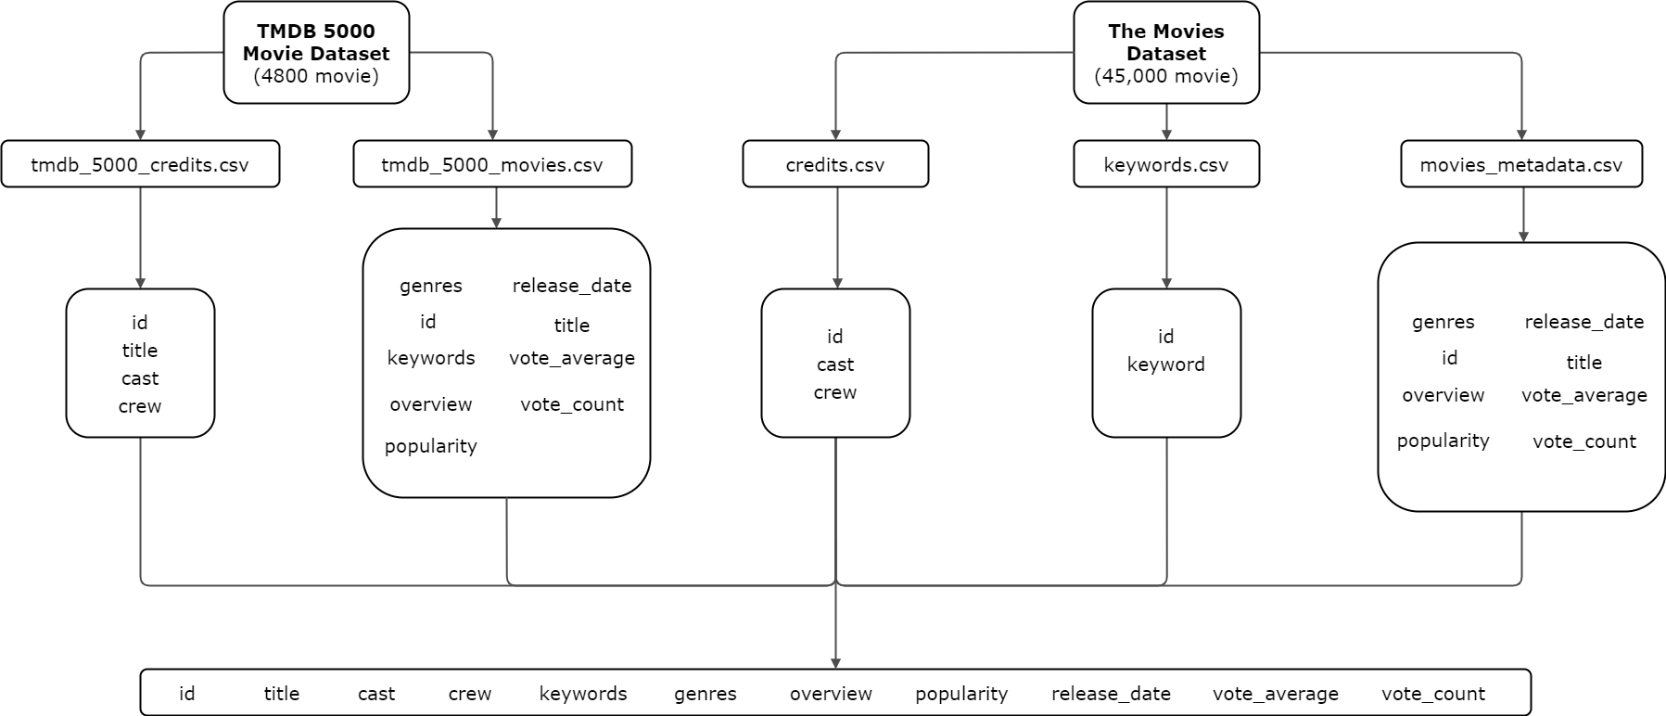

Figure 6: Merging Plan for "TMDb 5000 Movie Dataset" and "The Movies Dataset"

# Chapter 3: Methodology and Results

## 3.1 Data Importing and Merging

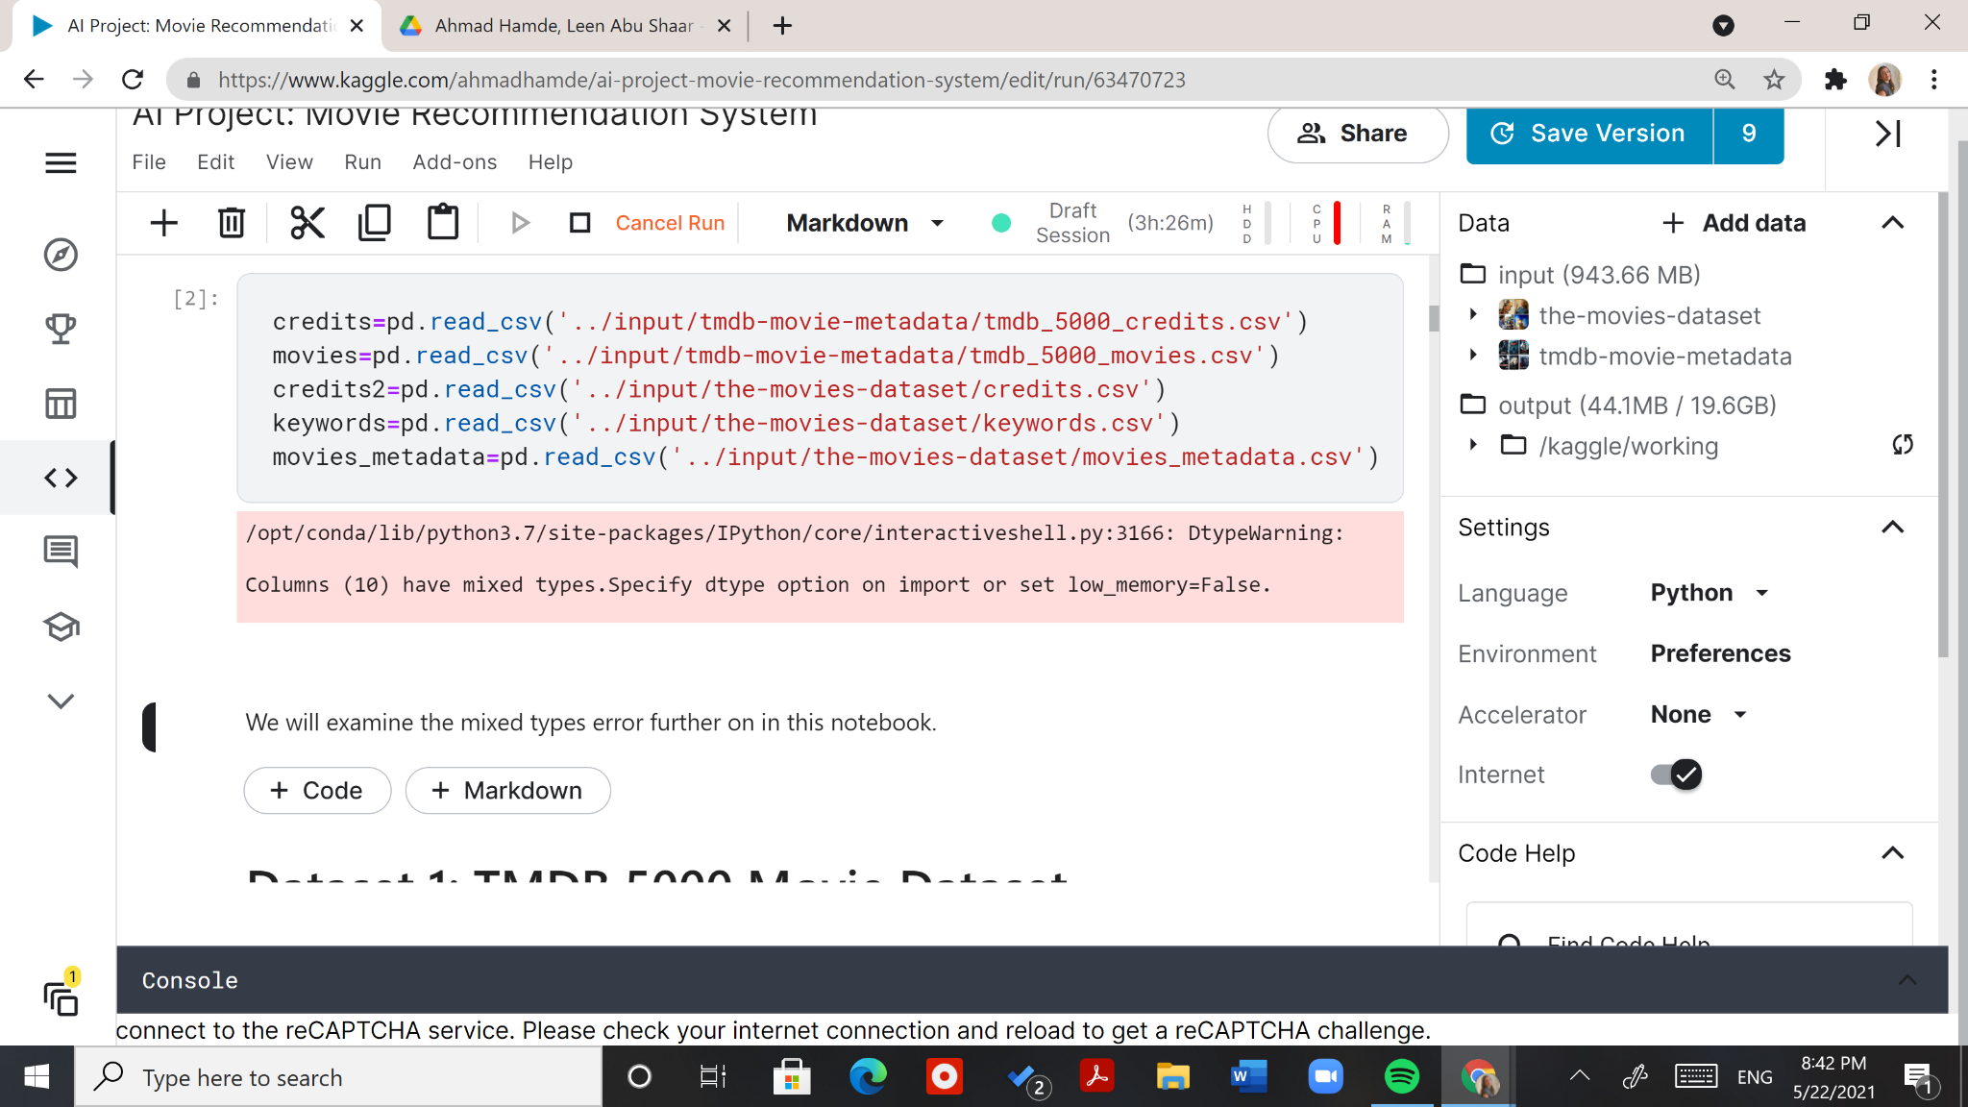Our dataset is made of five separate csv files, all in which have common columns. The first two files are from the first dataset: “TMDB 5000” and the rest are from the second dataset: “The Movies Dataset,” as shown in Figure 7 below.

Figure 7: Importing of Datasets

Our first dataset merges the first two files and drops irrelevant attributes. In Figure 8 below, we can see that the resulting first dataset has one missing "release_date" value and three missing "overview" values. We will fill the "release_date" value with an empty string and keep the 4,800 movies with an "overview." This is because 3/4,803 is a small number and having no overview will affect the recommendation result.

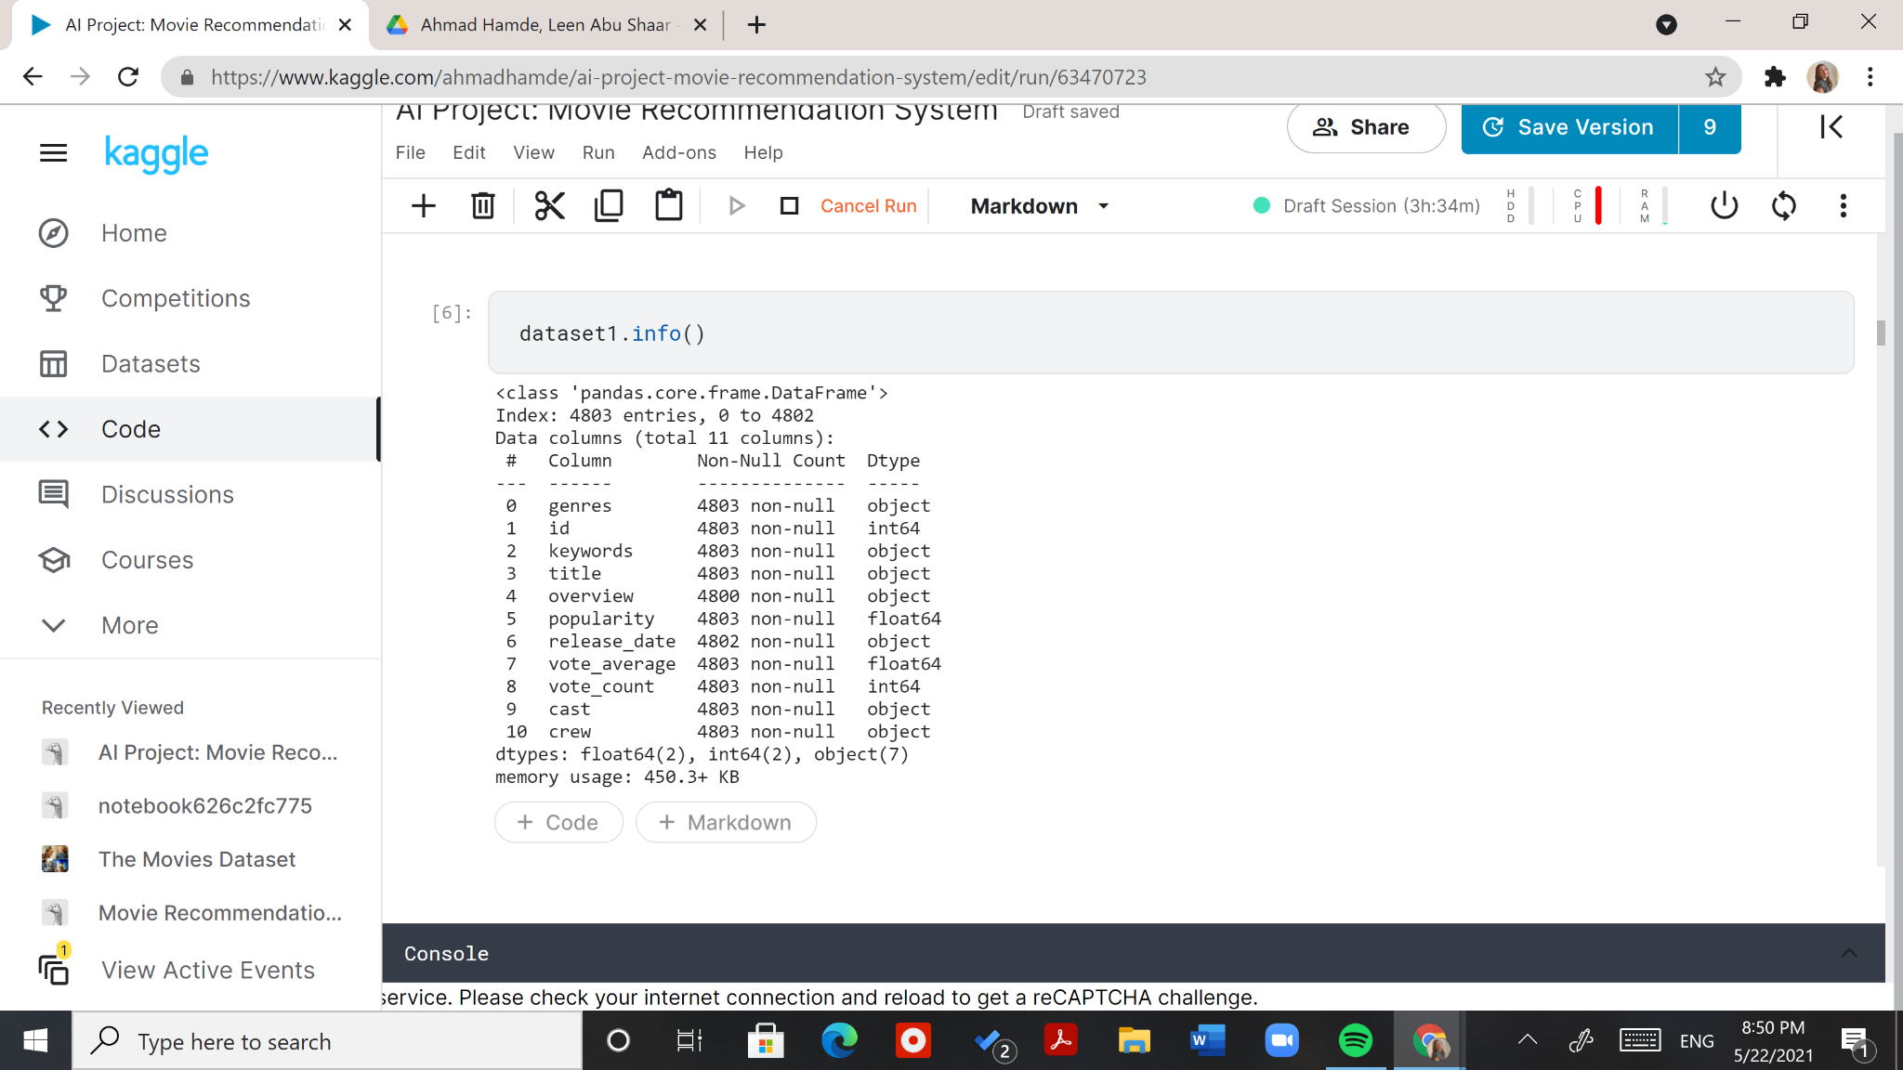

Figure 8: First Dataset Information

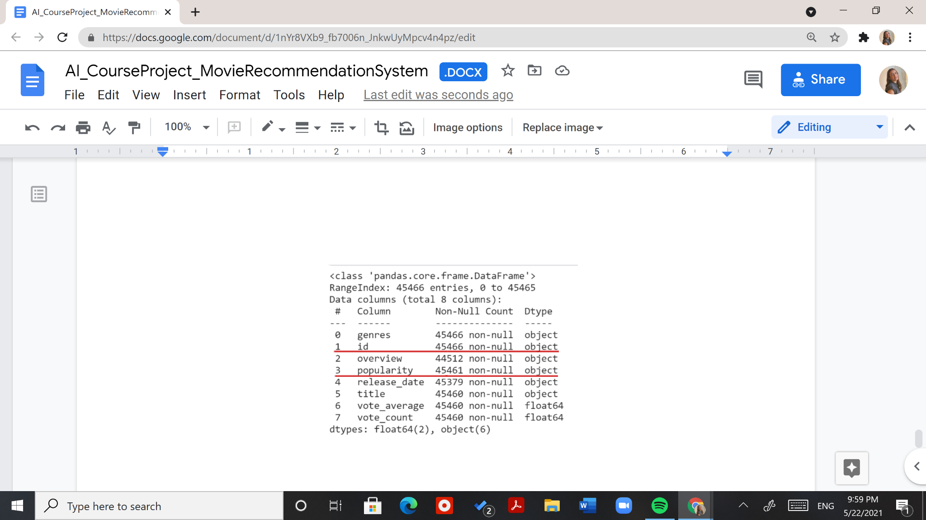Our second dataset merges the last three files: “credits.csv,” “keywords.csv” and “movies_metadata.csv.” This was a bit trickier than the first two files due to the existence of inaccurate data leading to a mismatch in data types. Figure 9 shows the attributes with the mismatching types underlined in red.

Figure 9: Incorrect Data Types in First Dataset

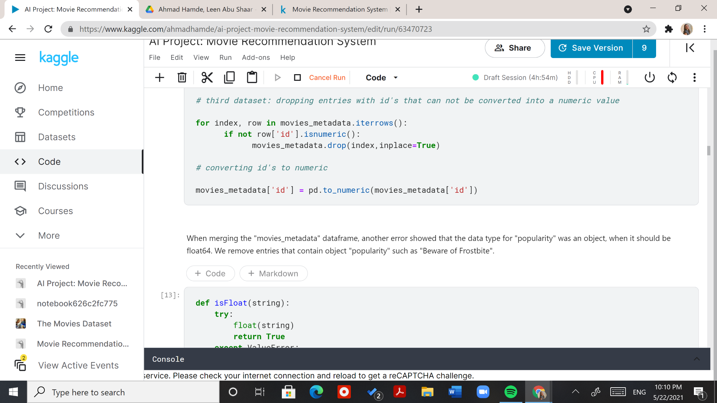Figures 10 and 11 below show the approach taken in dropping the rows with inaccurate data and converting the data types.

Figure 10: Converting the "id" Values to Integers

Figure 11: Converting the "popularity" Values to Float Values

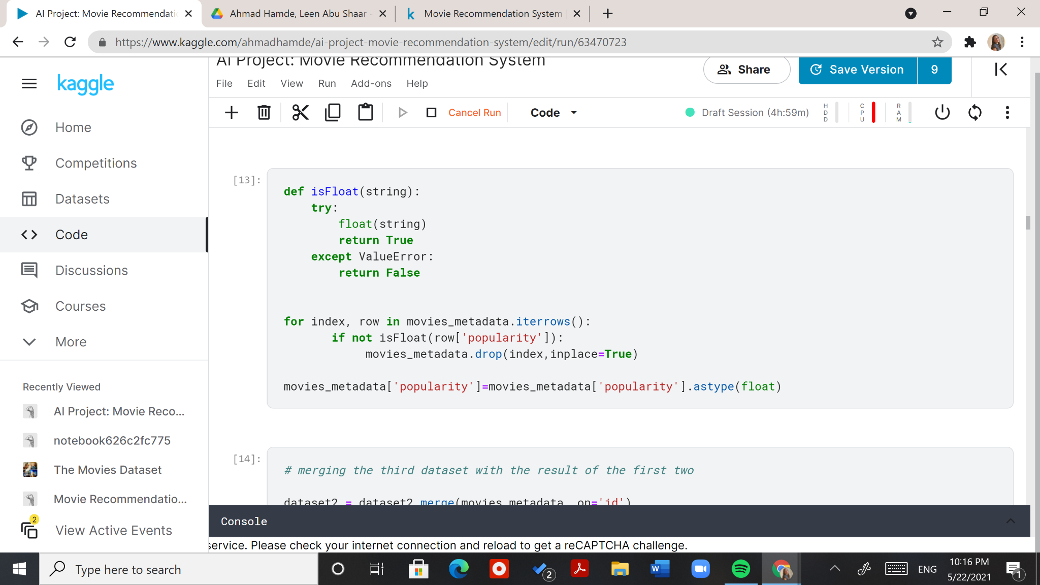We can note that in Figure 9, there are various numbers of non-null data entries, meaning the dataset is filled with null values. This was solved by dropping 995 movies. In the scope of this project, this was afforded as there were many missing “overviews,” and our system highly depends on those. An alternative solution would be to fill the null values with their respective “overviews” by mapping our dataset to another with an “imdb_id” and “overview” attribute pair.

After merging the files within each dataset into two separate data frames, we concatenated them and dropped duplicates. This resulted in our main data frame “movie_collection,” which contains 41,730 movies with our 11 chosen attributes.

## 3.2 Data Preprocessing

### 3.2.1 Preprocessing of Genres

Since the “genres” attribute contained the genres of each movie in a list of dictionaries, there was a need for encoding it to a meaningful format. We first iterated over the data frame rows and extracted a list of all unique genres. Then, we substituted the combined “genres” attribute with an attribute for each genre.

We then iterated over the rows again and filled the values of our new attributes with a Boolean value: 1 if the movie has this specific genre and 0 if it does not. Both times genres in the list of dictionaries were extracted by the regular expression module’s method “search” as shown in Figure 12 below.

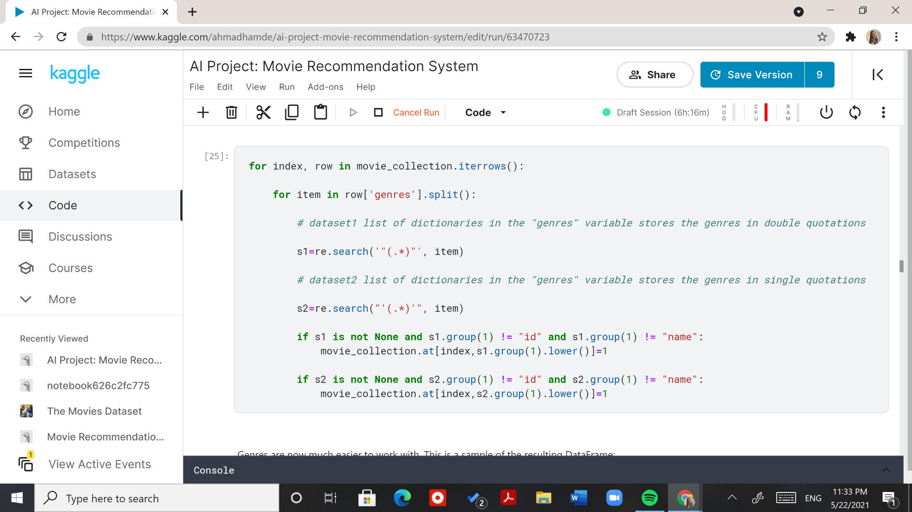

Figure 12: Setting the Genre Attributes for Movies

Let us trace the code in Figure 12 and iterate over the movie “Toy Story.”

1. row[‘genres’]:

[{'id': 16, 'name': 'Animation'}, {'id': 35, 'name': 'Comedy'}, {'id': 10751, 'name': 'Family'}]

1. items in row[‘genres’].split():

{'id': 16, 'name': 'Animation'},

{'id': 35, 'name': 'Comedy'},

{'id': 10751, 'name': 'Family'}

1. s2.group(1) represents any string inside single quotations:

“id”, “name”, “Animation” for the first item.

“id”, “name”, “Comedy” for the second item.

“id”, “name”, “Family” for the third item.

We take any s2.group(1) value that is not null (or None), “id”, or “name” and set the attribute with the name of the genre at that specific row to 1 by this line of code: movie_collection.at[index, s2.group(1).lower()] = 1

Therefore, Toy Story will have attributes “animation”, “comedy” , and “family” set to 1.

The resulting genre attributes are shown in Figure 13 below.

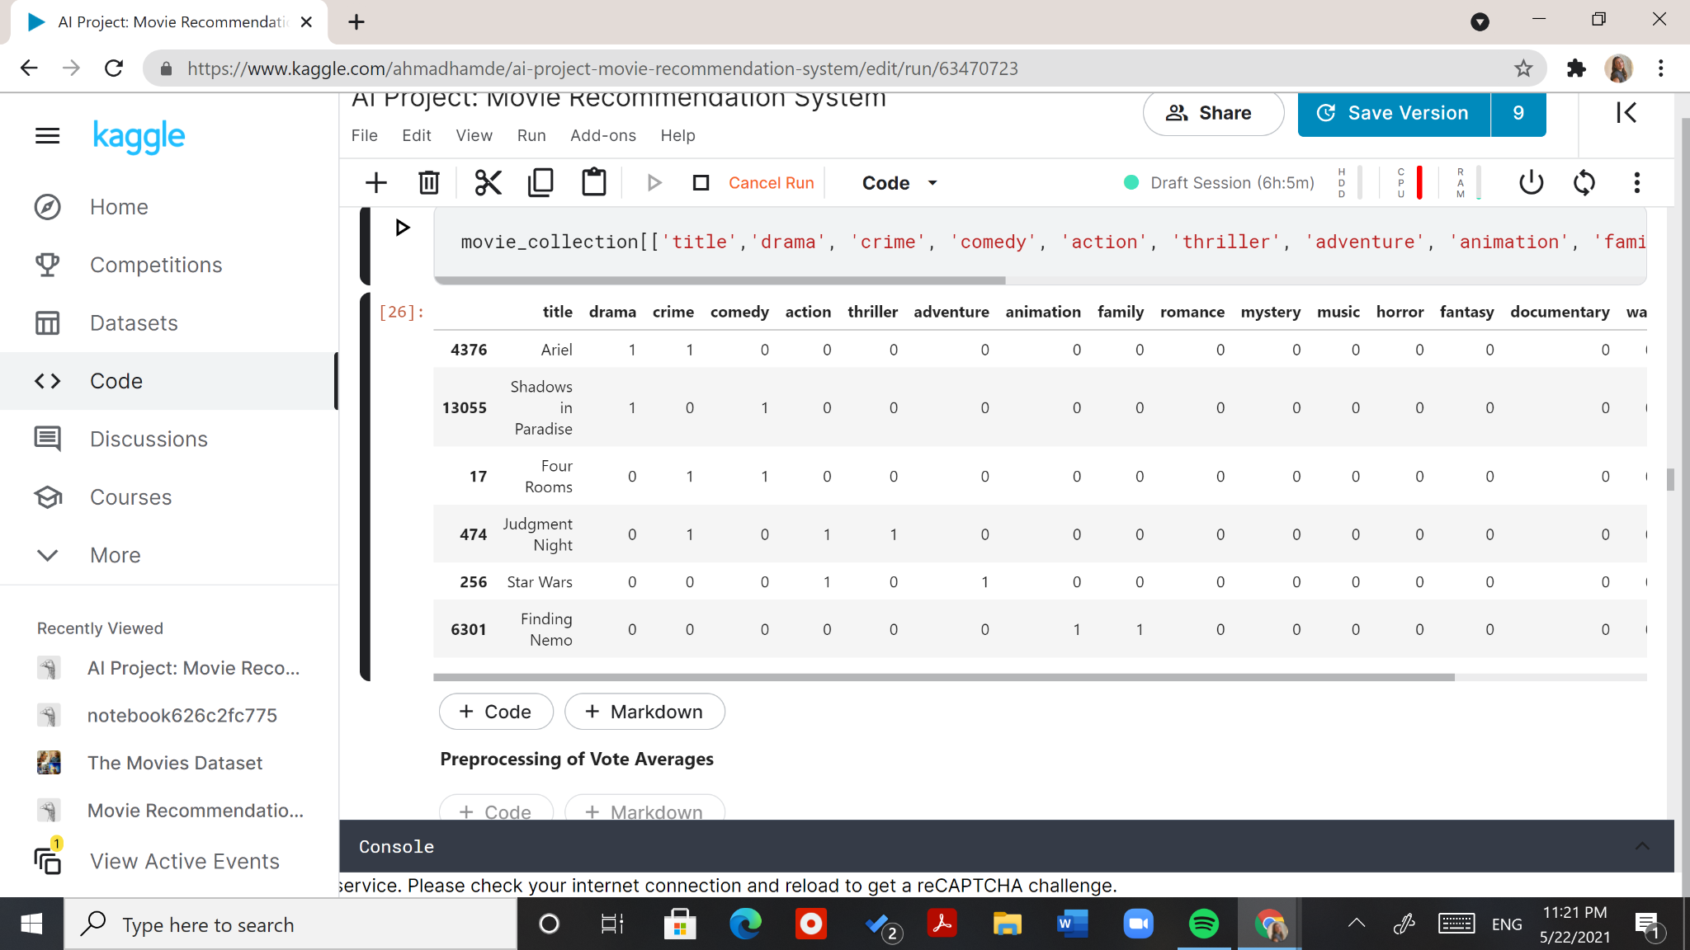

Figure 13: Sample Data Showing Genre Attributes

### 3.2.2 Preprocessing of Vote Averages

Our data frame “movie_collection” contains two attributes “vote_average” and “vote_count.” Using the vote average as a measure on its own would be inaccurate. For instance, if one movie has a vote average based on one voter, while another has a vote average based on a thousand voters, the rating for the first movie will be biased. Since the vote counts are not a controlled variable, we calculate the weighted rating which gives a better indication of the movies’ actual ratings. Figure 14 below shows the IMDb formula used to calculate the weighted rating.

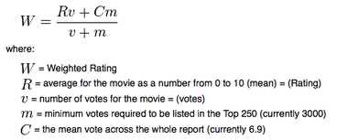[7]

Figure 14: IMDb's Weighted Rating Former Formula

The value of variables in the equation in Figure 14 above are easily extracted from our dataset. We used the code written by the author of our literature review project, Ibtesam. The code along its output are shown in Figure 15 below.



Figure 15: Application of IMDb's Weighted Rating Formula and Resulting Attribute Values

Lastly in data processing, we had to reduce the data as our Kaggle notebook crashed in our approaches due to an error indicating a lack of memory allocated. This error is shown in Figure 16 below.

Figure 16: Kaggle's Error for Exceeded Memory Allocation

To fix this, we took a subset of our movies keeping only the movies with a weighted average rating higher than 5.75, as shown in Figure 17 below



Figure 17: Filtering Data to Movies with a Rating Higher than 5.75

## 3.3 Data Visualization

As a starting point for visualizing our data, we looked at six different plots. The plots are shown in Figures 18-23, along with observations on each.

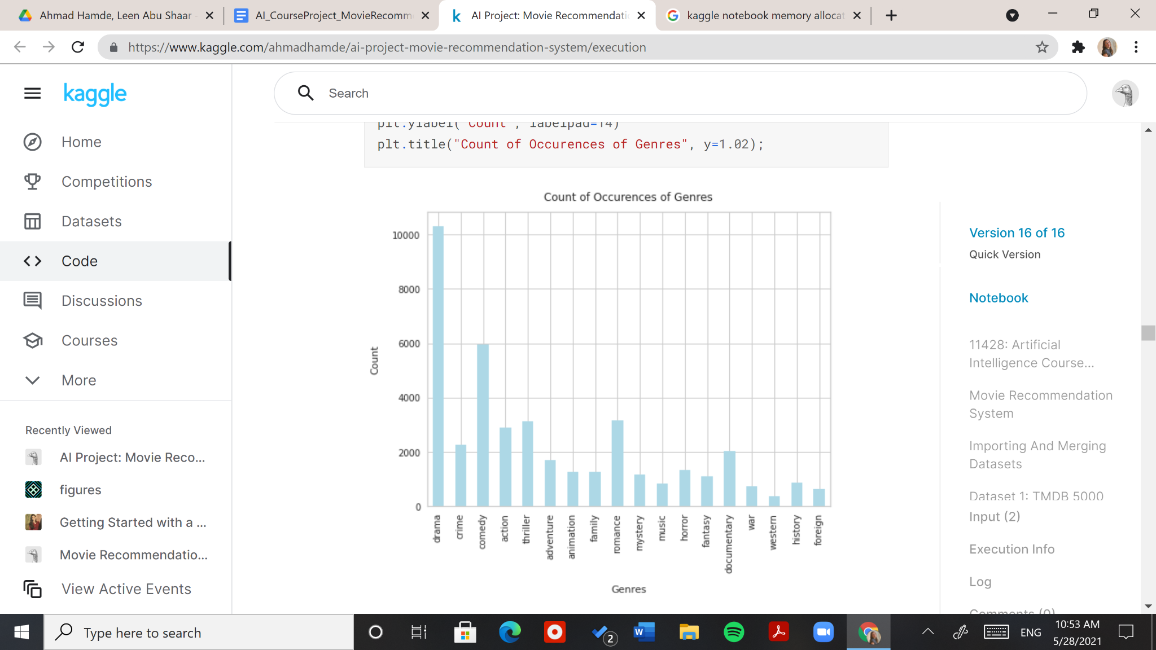Figure 18 below shows the count plot of genres.

Figure 18: Bar Plot Showing Count of Genres

The genre counts indicate that the data is not very diverse. About 10,000 movies in our data consist of drama movies.

Figure 19 below shows the histogram of popularity scores.

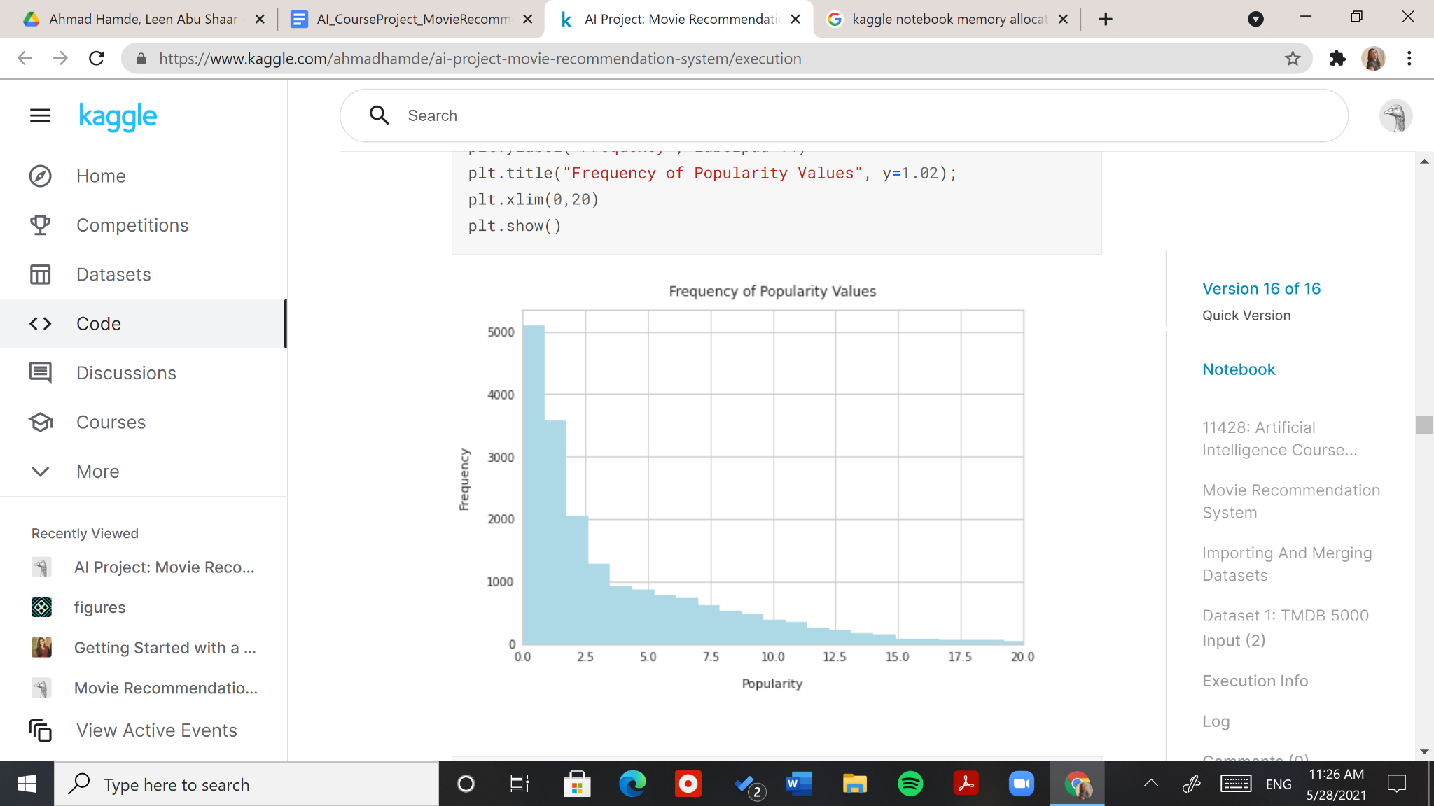

Figure 19: Histogram of Popularity Scores

We can see that the popularity scores are a little variant, and there are more movies with a low popularity value than a high popularity value. We should look for data that is more normalized to improve this limitation.

Figure 20 below shows the histogram of weighted average ratings.

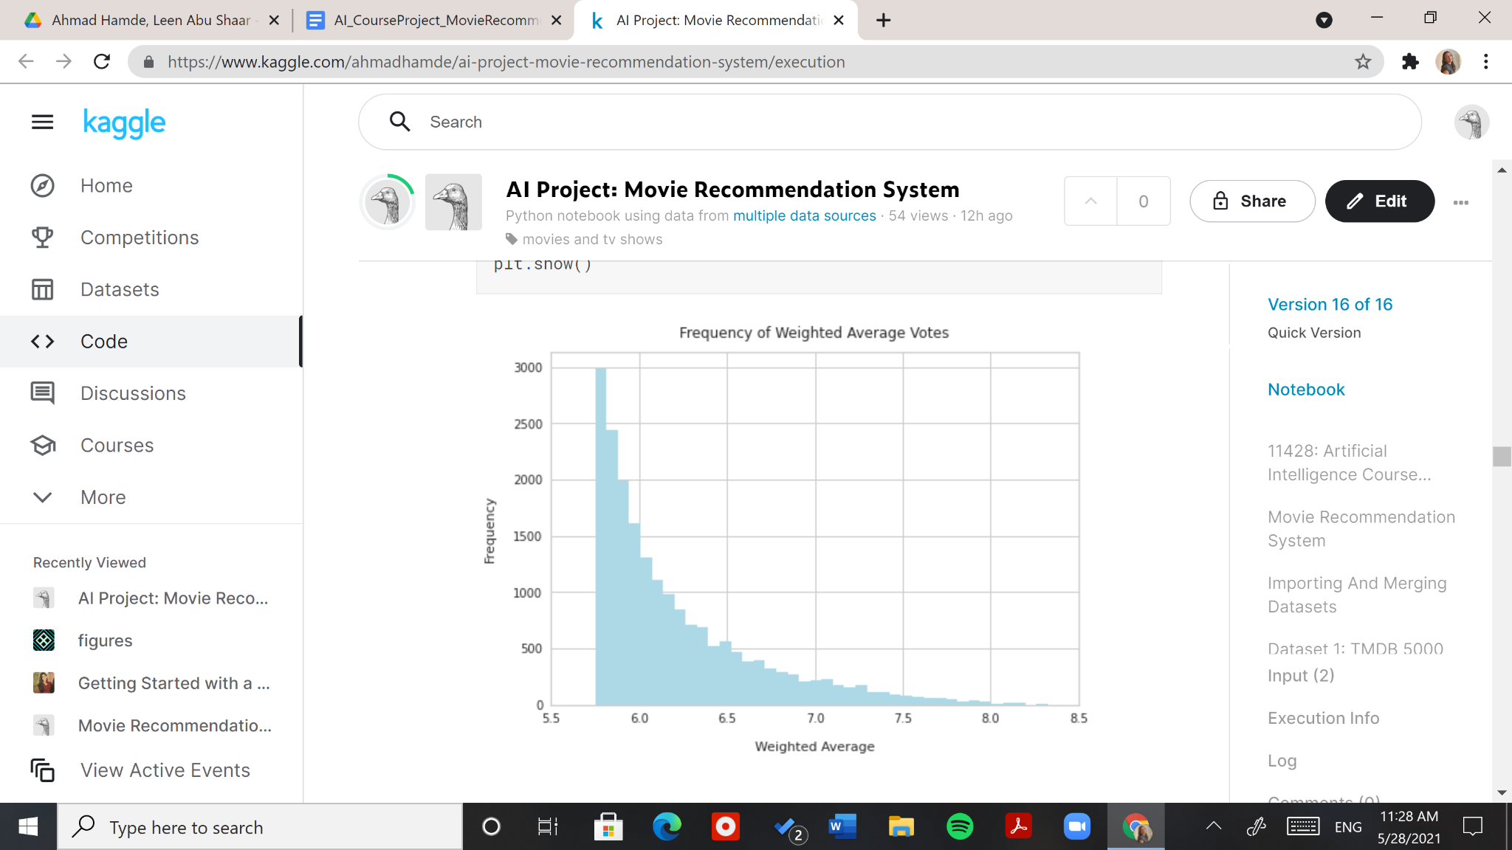

Figure 20: Histogram of Weighted Average Ratings

The same note that applies to popularity applies to the weighted average rating. In this plot, we can notice that all movies with a rating lower than 5.75 were indeed removed from our data.

Figure 21 below shows the histogram of release years.

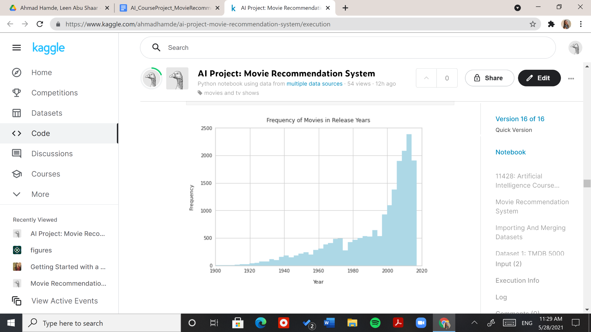

Figure 21: Histogram of Movie Release Years

This plot gives an important observation. The datasets we used for our project were lastly updated in 2017, meaning our count plot does not include any movies from our current times, as shown in the blank white area of the plot. This emphasizes on the importance of an up-to-date recommendation system that automatically adds new movies. You may ask: what about the fact that new movies have no ratings or enough content to base our recommendations on yet? The solution to this is: collaborative filtering systems. This is why a combination of both content-based and collaborative filtering systems is usually preferred.

Figure 22 below shows the box plot of popularity scores.

Figure 22: Box Plot of Popularity Scores

We can conclude that the "popularity" attribute has a few outliers, as its mean is 2.5, while its highest value is 15.0. The range of values is quite large (15.0).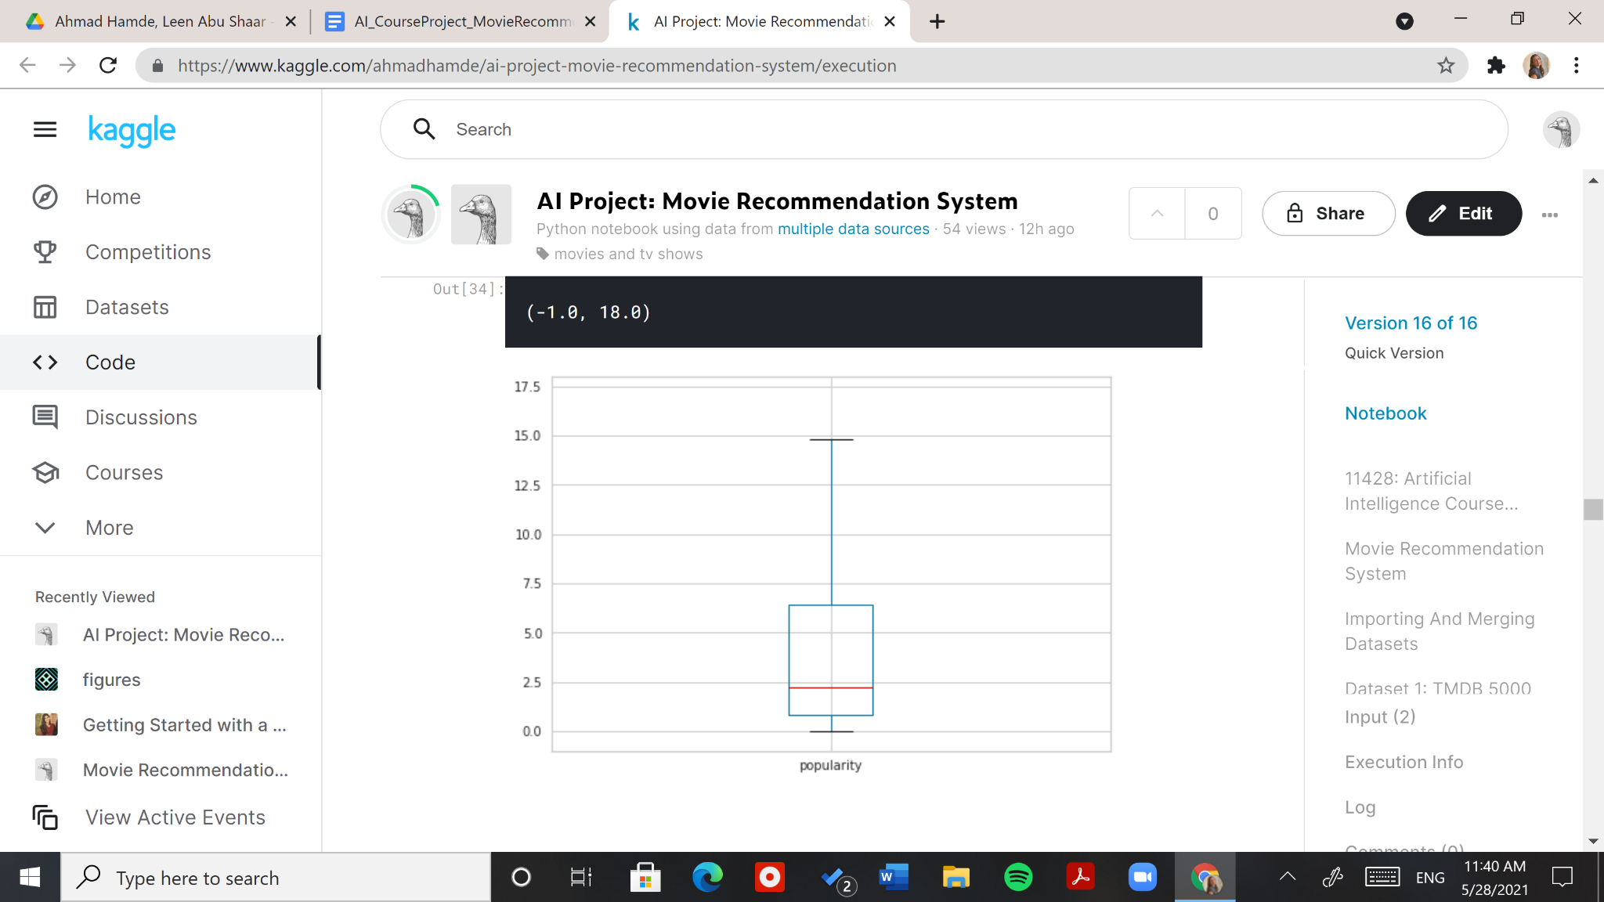

Figure 23 below shows the box plot of weighted average ratings.

Figure 23: Box Plot of Weighted Average Ratings

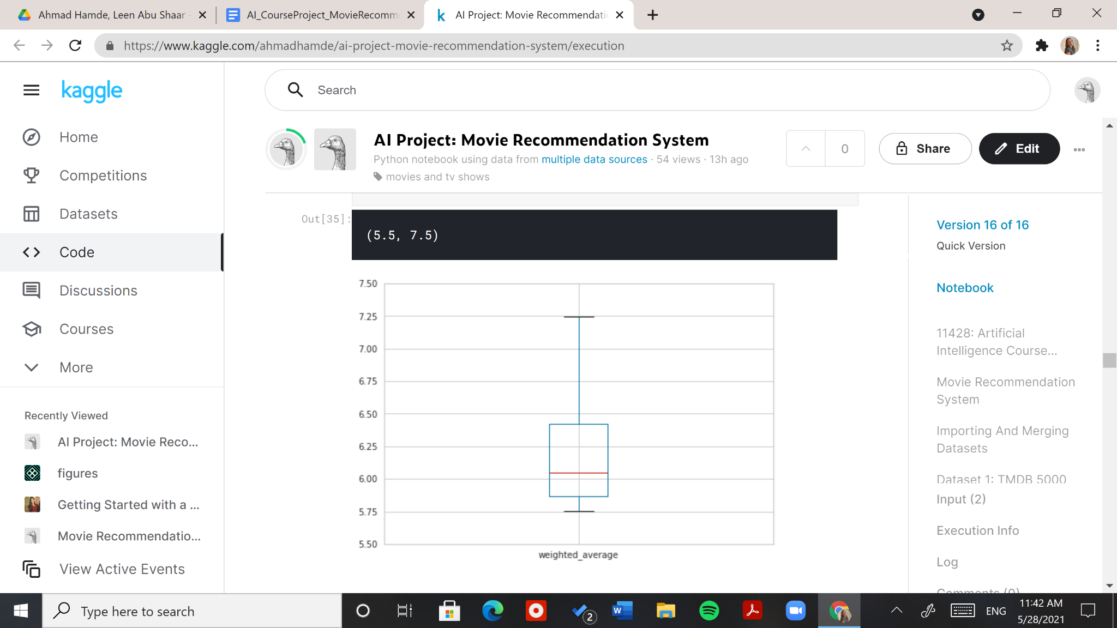

As for the "weighted_average" attribute, the range of values is small (1.5) compared to the "popularity" attribute above.

## 3.4 Approaches

### 3.4.1 Demographic Filtering to Introduce Recommendation Systems

We first use a bar plot to show the top 10 movies with highest popularity scores after sorting our data in descending order by popularity score. The plot is shown in Figure 24 below.

Figure 24: Bar Plot Showing the Ten "Most Popular" Movies

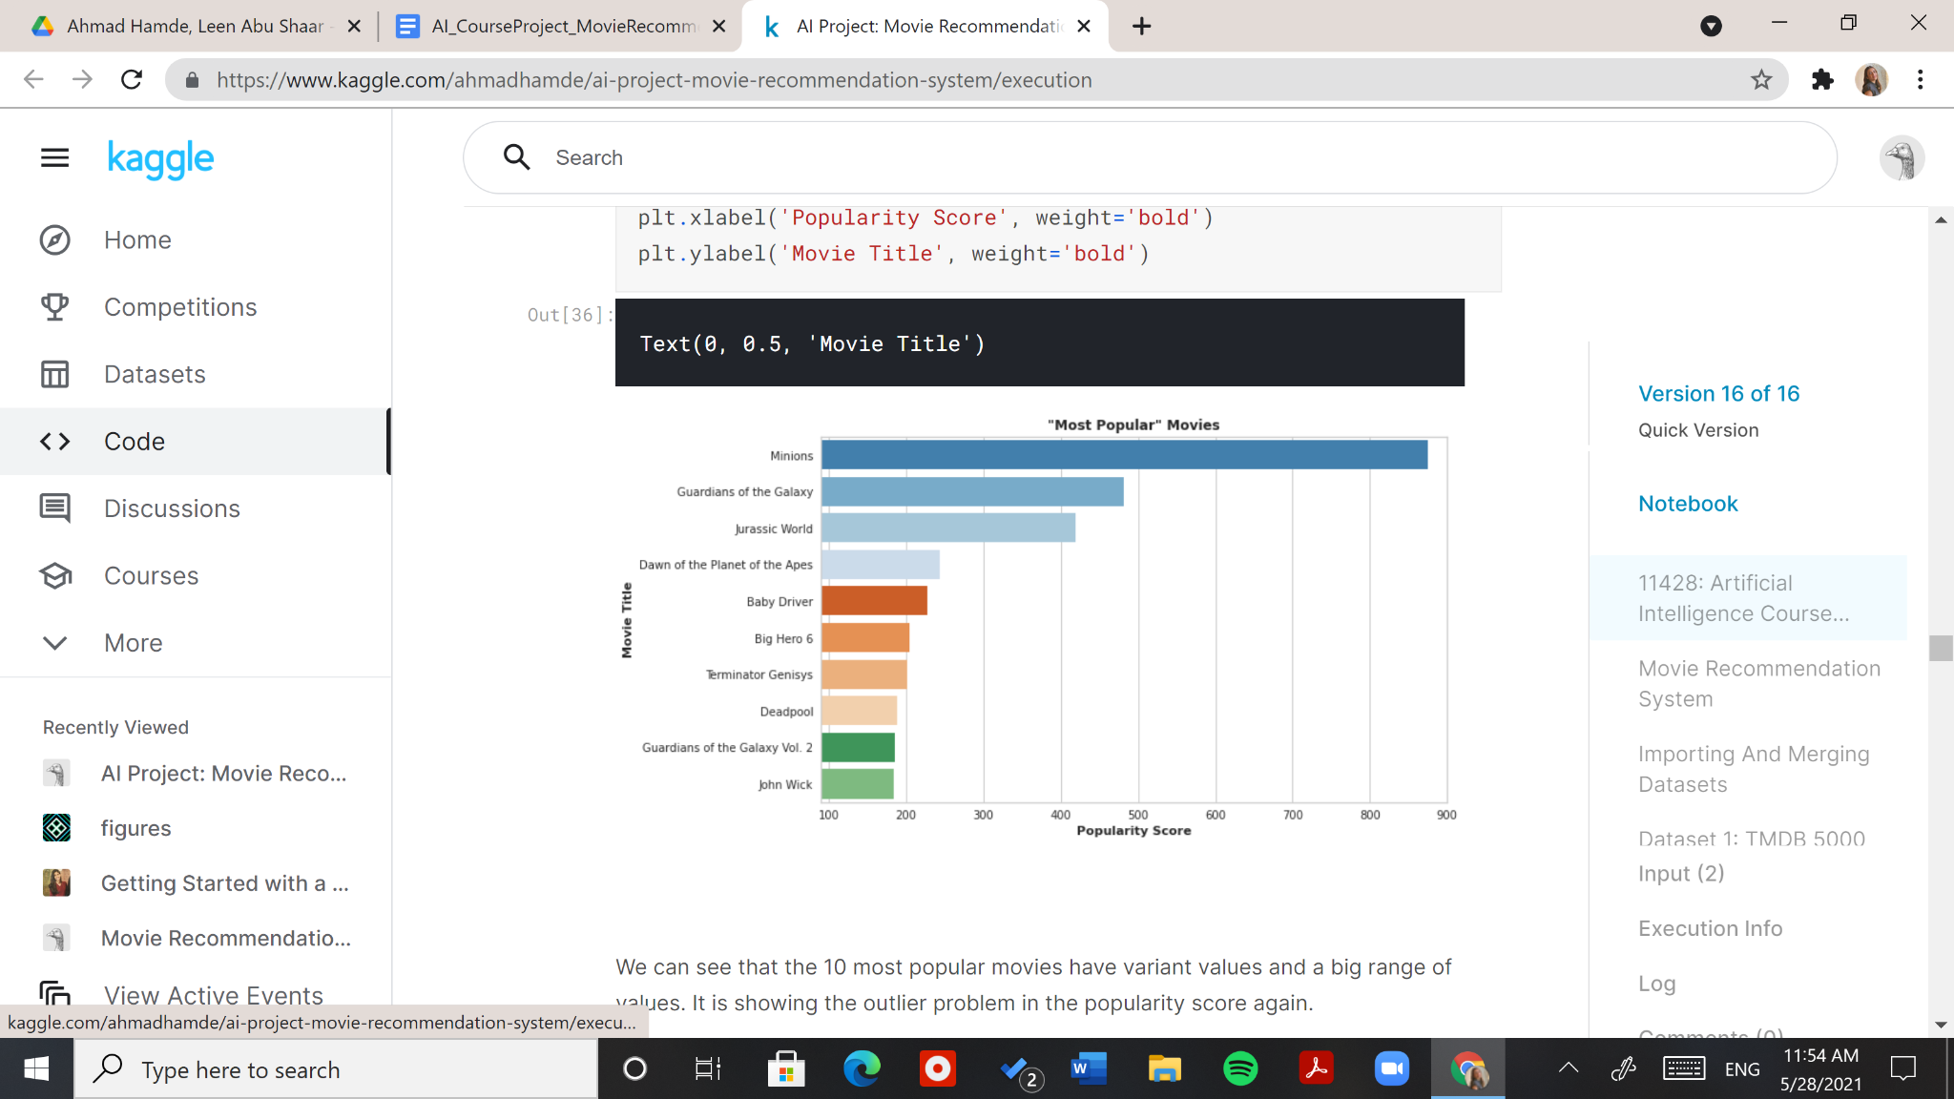

We can see that the 10 most popular movies have variant values and a big range of values. It is showing the outlier problem in the popularity score again.

We then use another bar plot to show the 10 highest rated movies after sorting our data in descending order by weighted average rating. The plot is shown in Figure 25 below.

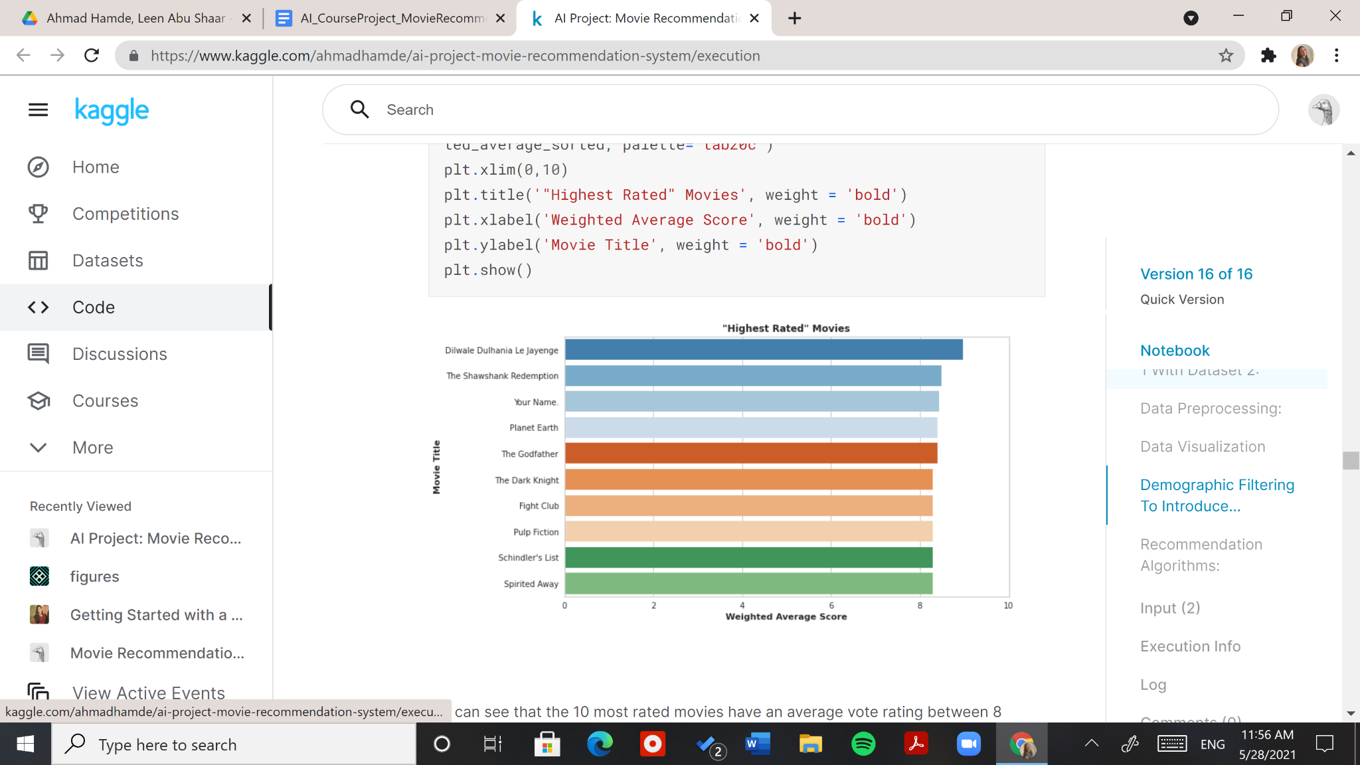

Figure 25: Bar Plot Showing the Ten "Highest Rated" Movies

We can see that the 10 most rated movies have an average vote rating between 8 and 9.

We proceed to calculate a score that combines the weighted average and the popularity. As the weighted average score seemed more normalized to us, we attempted giving it a higher weight in our score. However, after experimentation with different weights, our selections were: 0.5 for the "weighted_average" and 0.5 for the "popularity," as shown in the score equation shown in Figure 26 below.

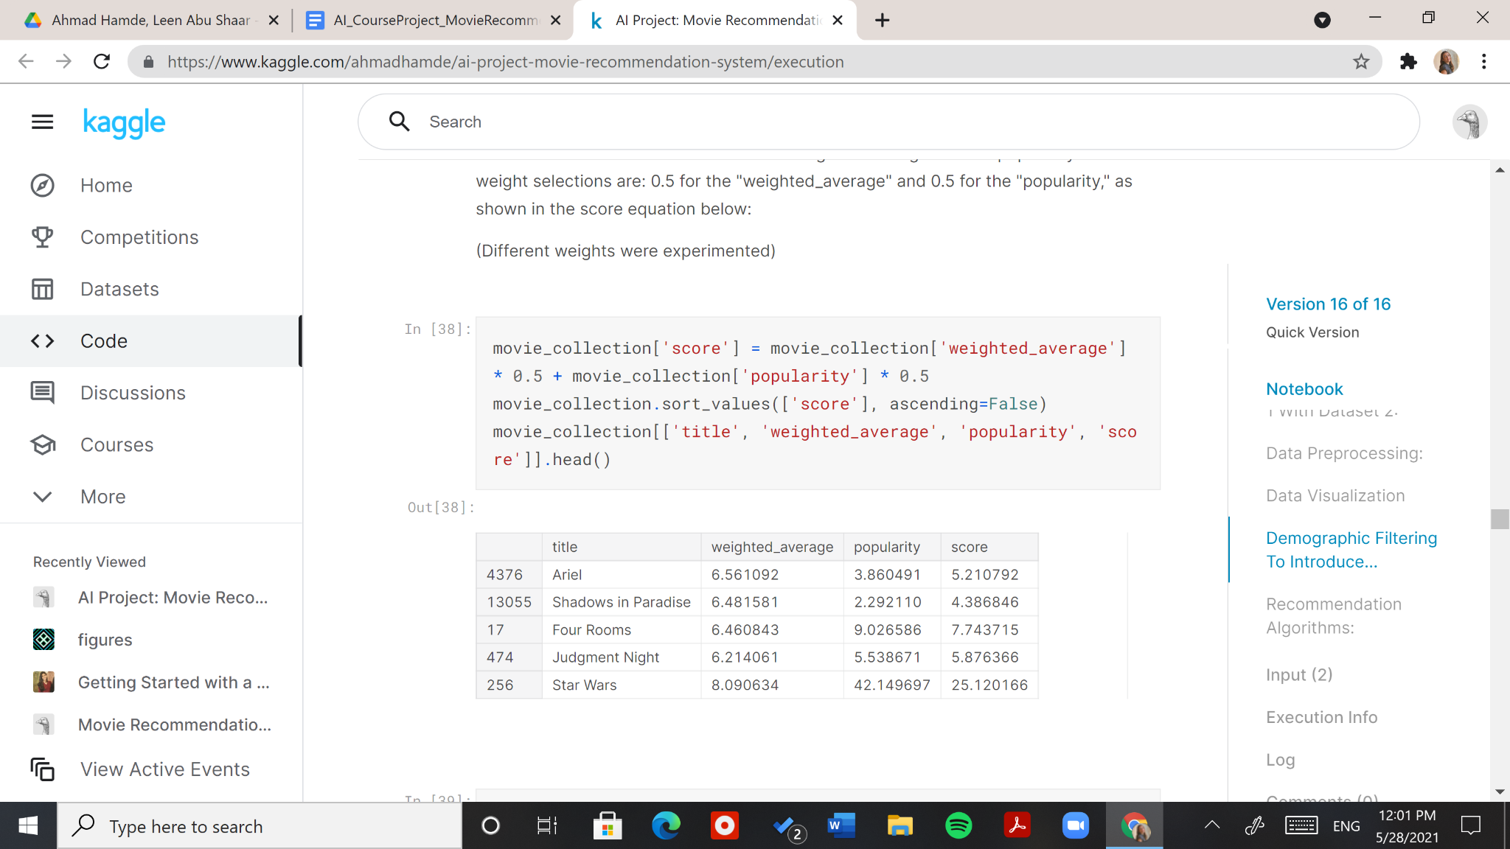

Figure 26: Score Value Calculation and Sample Values

This score will be used in subsection 3.4.3 for our first recommendation approach.

### 3.4.2 Failed Approach: Self-Organized Maps to Recommend Movies Based on Genre and Score

We started by training a 20x20 self-organized map network with 0.1 learning rate and 400,000 epochs. The input data we used for this contained the movie genres and scores. This approach was excluded as our SOM failed in grouping the movies into clear and distinct clusters, due to their variety, as shown in the scatter plot in Figure 27 below.

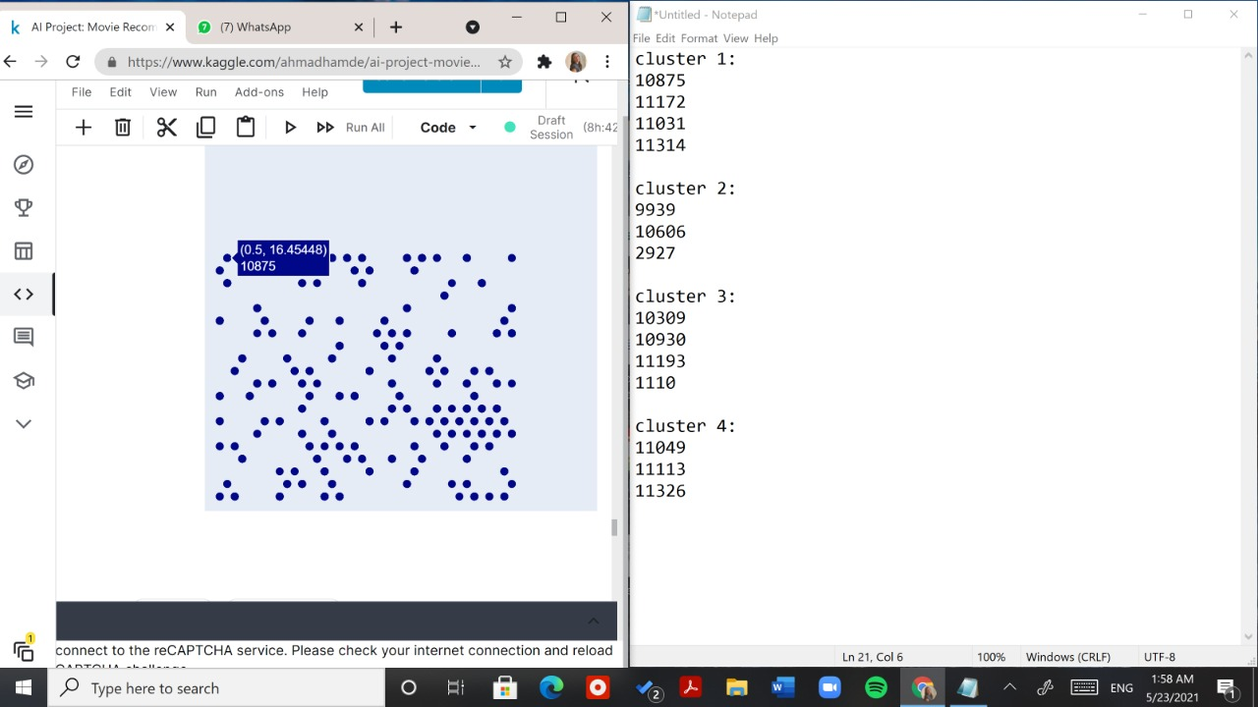

Figure 27: Scatter Plot Showing SOM Result

### 3.4.3 K-Means Clustering to Recommend Movies Based on Genre and Score

With research, we noticed that many movie recommendation projects used k-means clustering to recommend movies. Therefore, we tried it next. After scaling our input data (genres and score) using a StandardScaler, we started the process.

Firstly, we imported the methods shown in Figure 28 below.

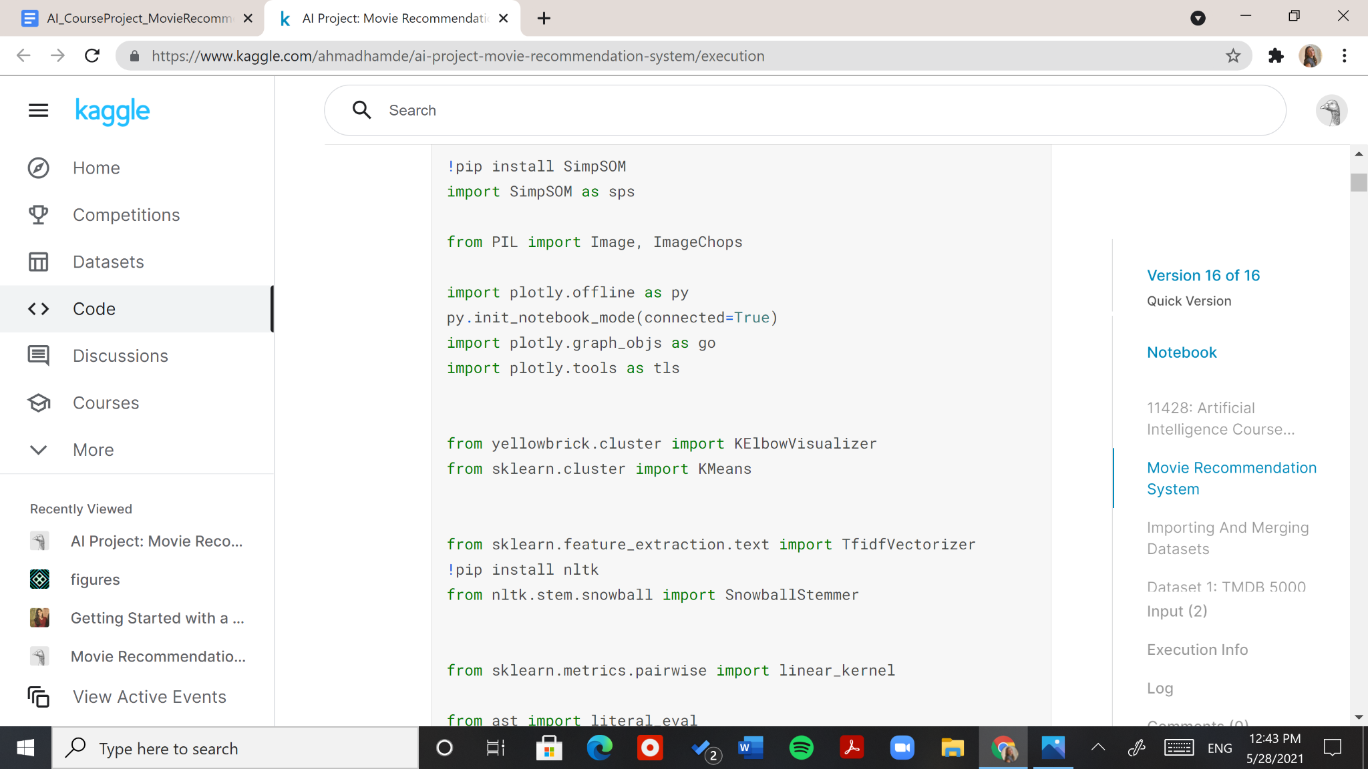

Figure 28: Importing Methods for k-Means Clustering

Before starting with the clustering method, we had to determine the number of clusters **(k)** we will be forming. In order to do that, we used the Elbow method; a method that visualizes a range of k values, in order to determine the optimum k value for the data we have. This happens when a graph of k values against a distortion score starts stabilizing forming an elbow shape. The method we imported for this specific approach in Figure 28 offered clear insights on our optimum k value as shown below in Figure 29.

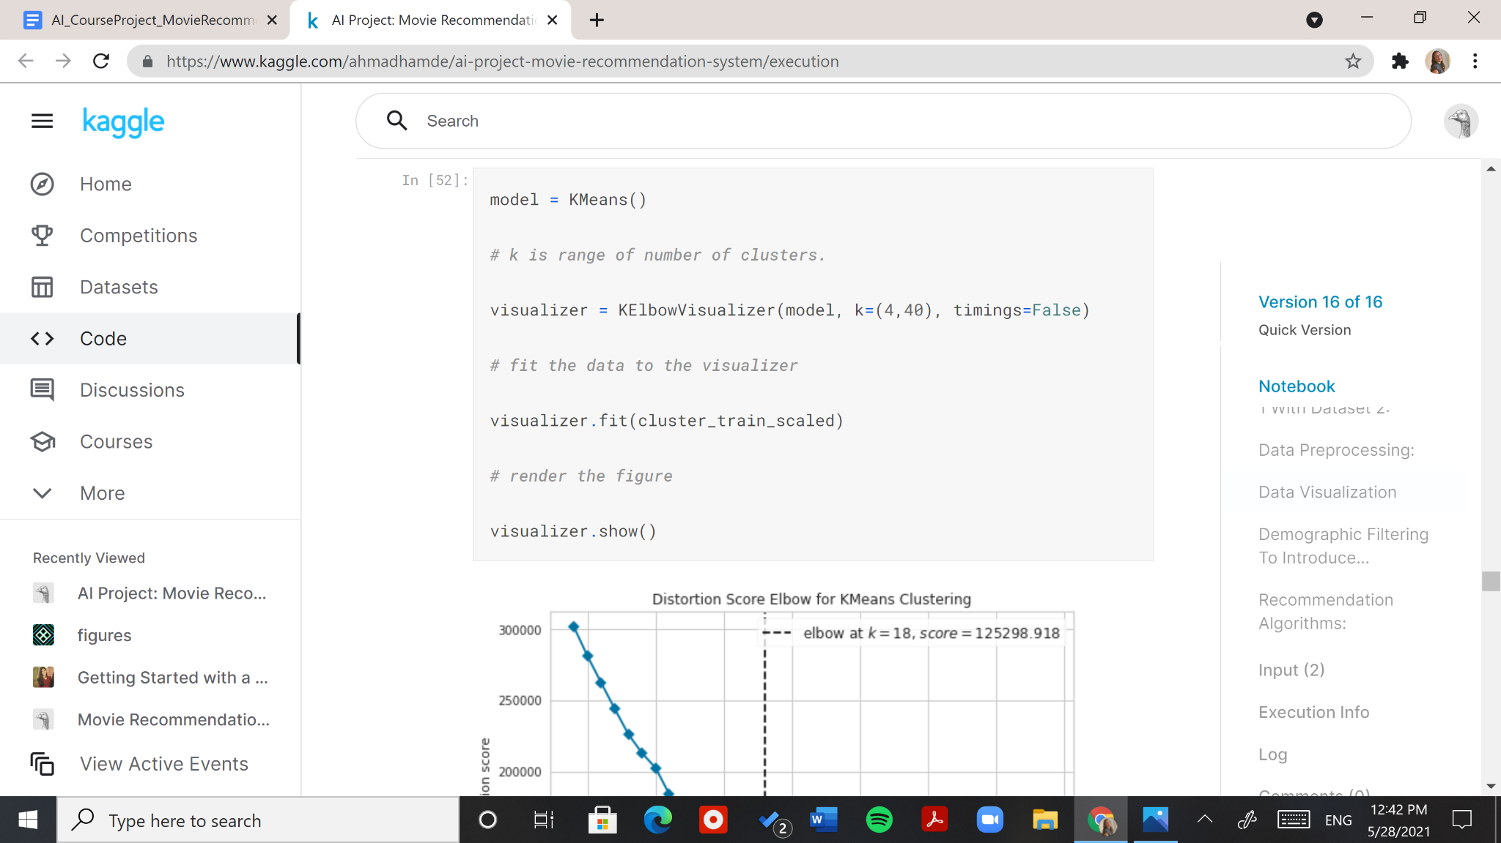

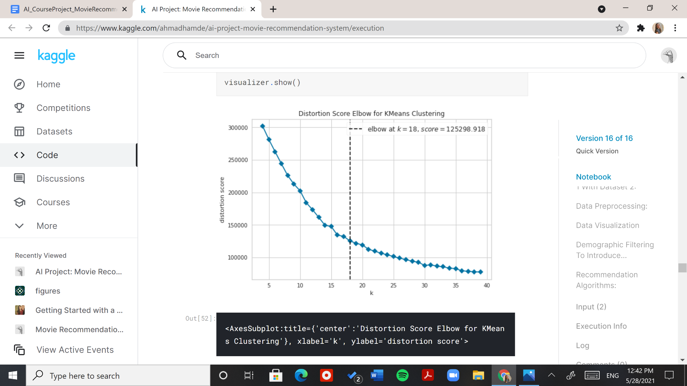

Figure 29: Elbow Visualizer with Output

We can observe from our elbow visualizer that the optimum number of clusters is equal to the number of genres, which is 18. This is interesting, as it indicates that the model could group movies with similar genres together.

We then created the model, fitted the data, and stored the cluster number for each movie in an attribute as shown in Figure 30 below.

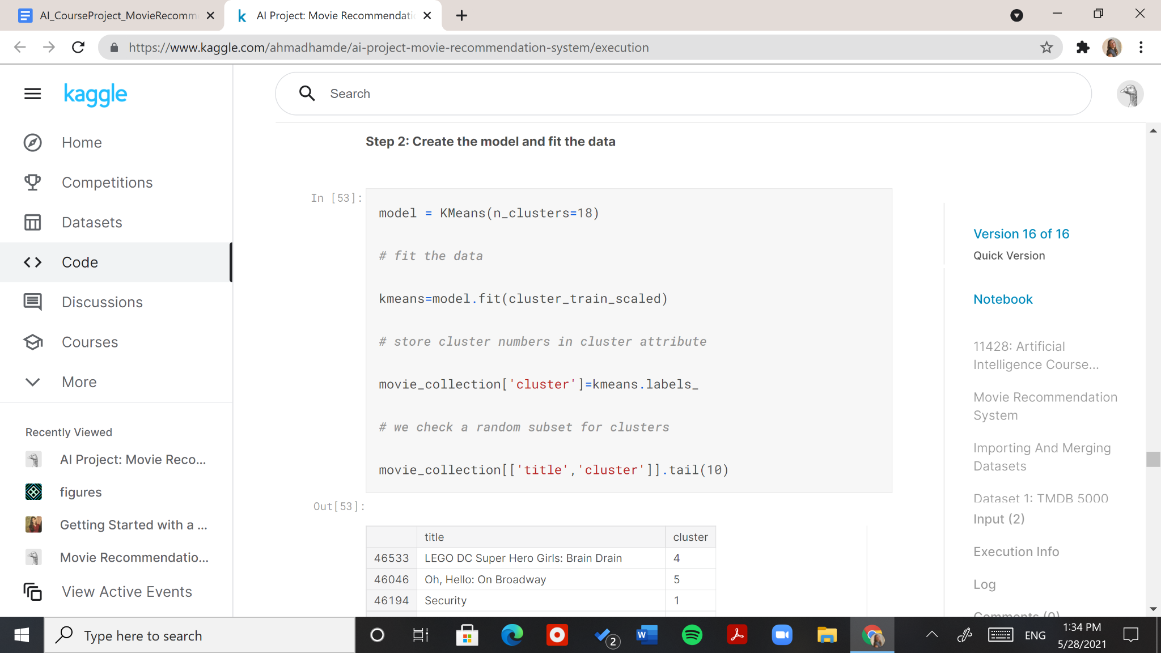

Figure 30: Implementing k-Means Clustering

The output of the cell in Figure 30 above is shown in Figure 31 below.

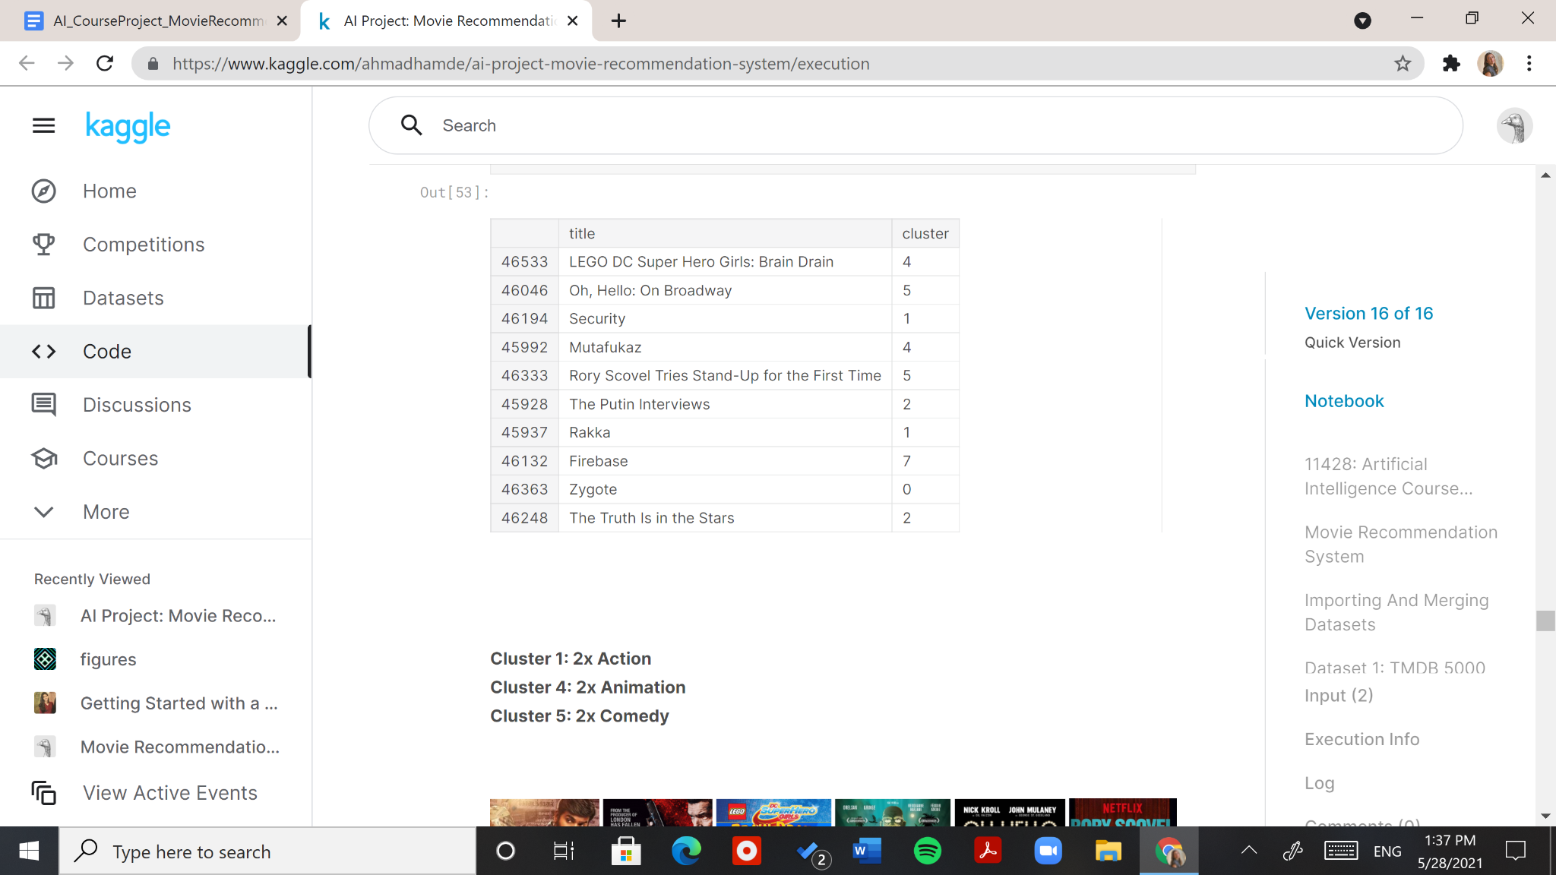

Figure 31: k-Means Clustering Labels Stored in "cluster" Attribute

The output in Figure 31 above showed promising results of the clusters formed. If we take a look at the movies with cluster number 1, we can see that they are both action movies. As for those with cluster number 4: animation movies, and those with cluster number 5: stand-up comedies. The posters of the mentioned movies are shown in Figure 32 in their respective order.



Figure 32: Movie Posters of Six Movies in Three Different Clusters (Action, Animation, and Comedy)

We moved on to visualizing how many movies each cluster contained, and this is shown in Figure 33 below.

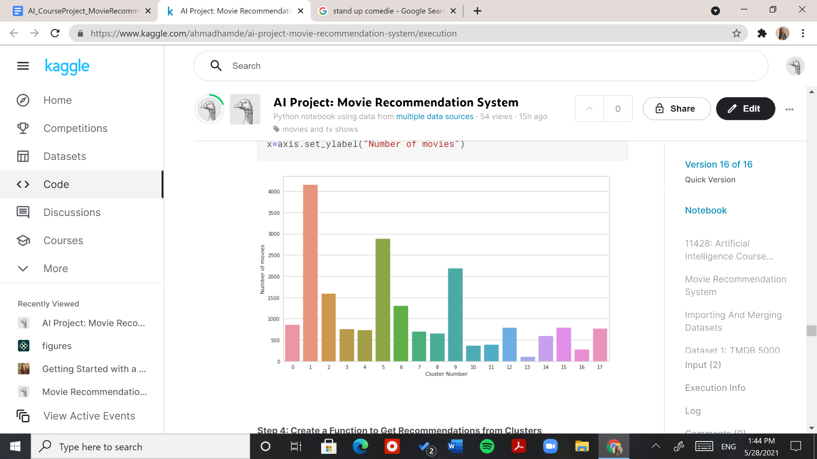

Figure 33: Bar Plot Showing the Count of Movies in Each Cluster

It seems like this bar plot is very similar in pattern to that for our count of genres in Figure 18: another interesting observation.

A key part of this recommendation approach is the function that gets the recommendations. We created it by first defining a Series for inverse indexing. This is done in order to allow the input of our function to be a movie title. The inverse indexing Series will take in a title and return the index of its row in our DataFrame as shown in Figure 34 below.

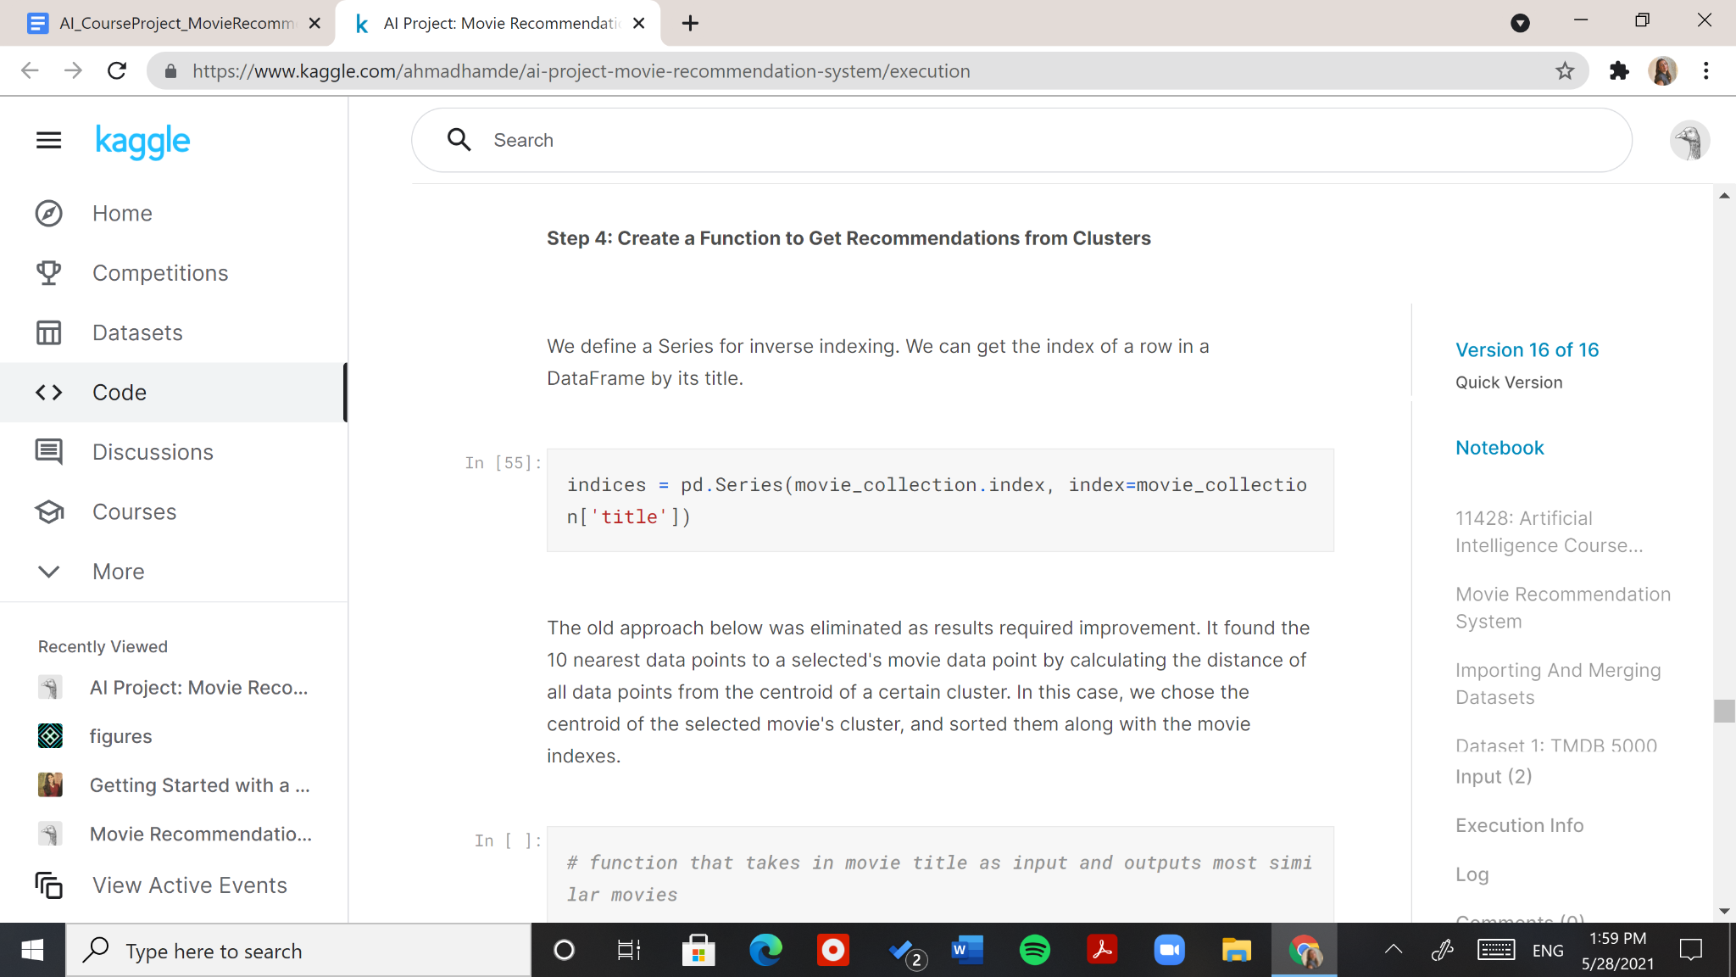

Figure 34: Inverse Indexing Variable

An old function we implemented calculated the distance between all data points from the centroid of a certain cluster and sorted them in ascending order along with their indexes in our movie dataset. This way we could choose the centroid of the selected movie’s cluster and find the nearest data points from it. We eliminated this function as results required improvement.

Our current function determines the cluster number of a selected movie and recommends the next 9 movies with a score higher than that of the selected movie from that same cluster. Its implementation is shown in Figure 35 below.

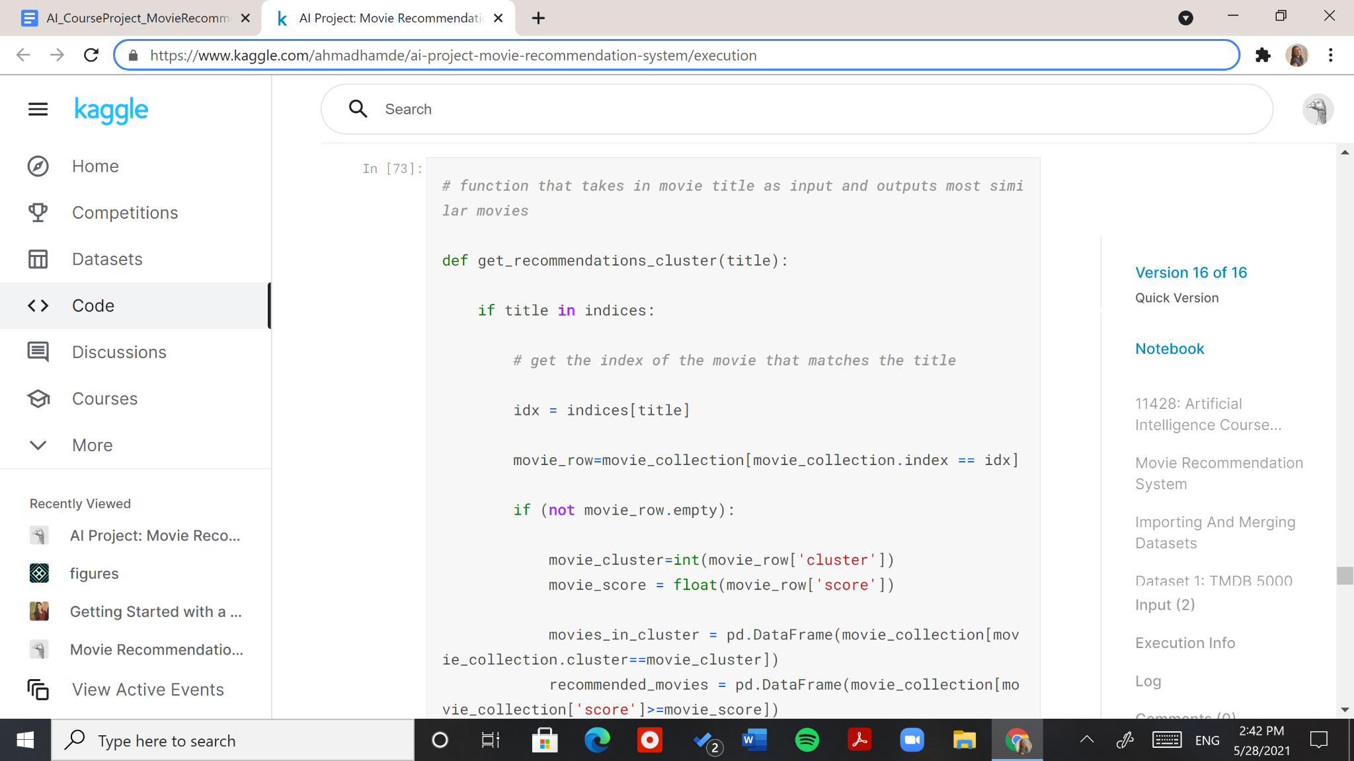

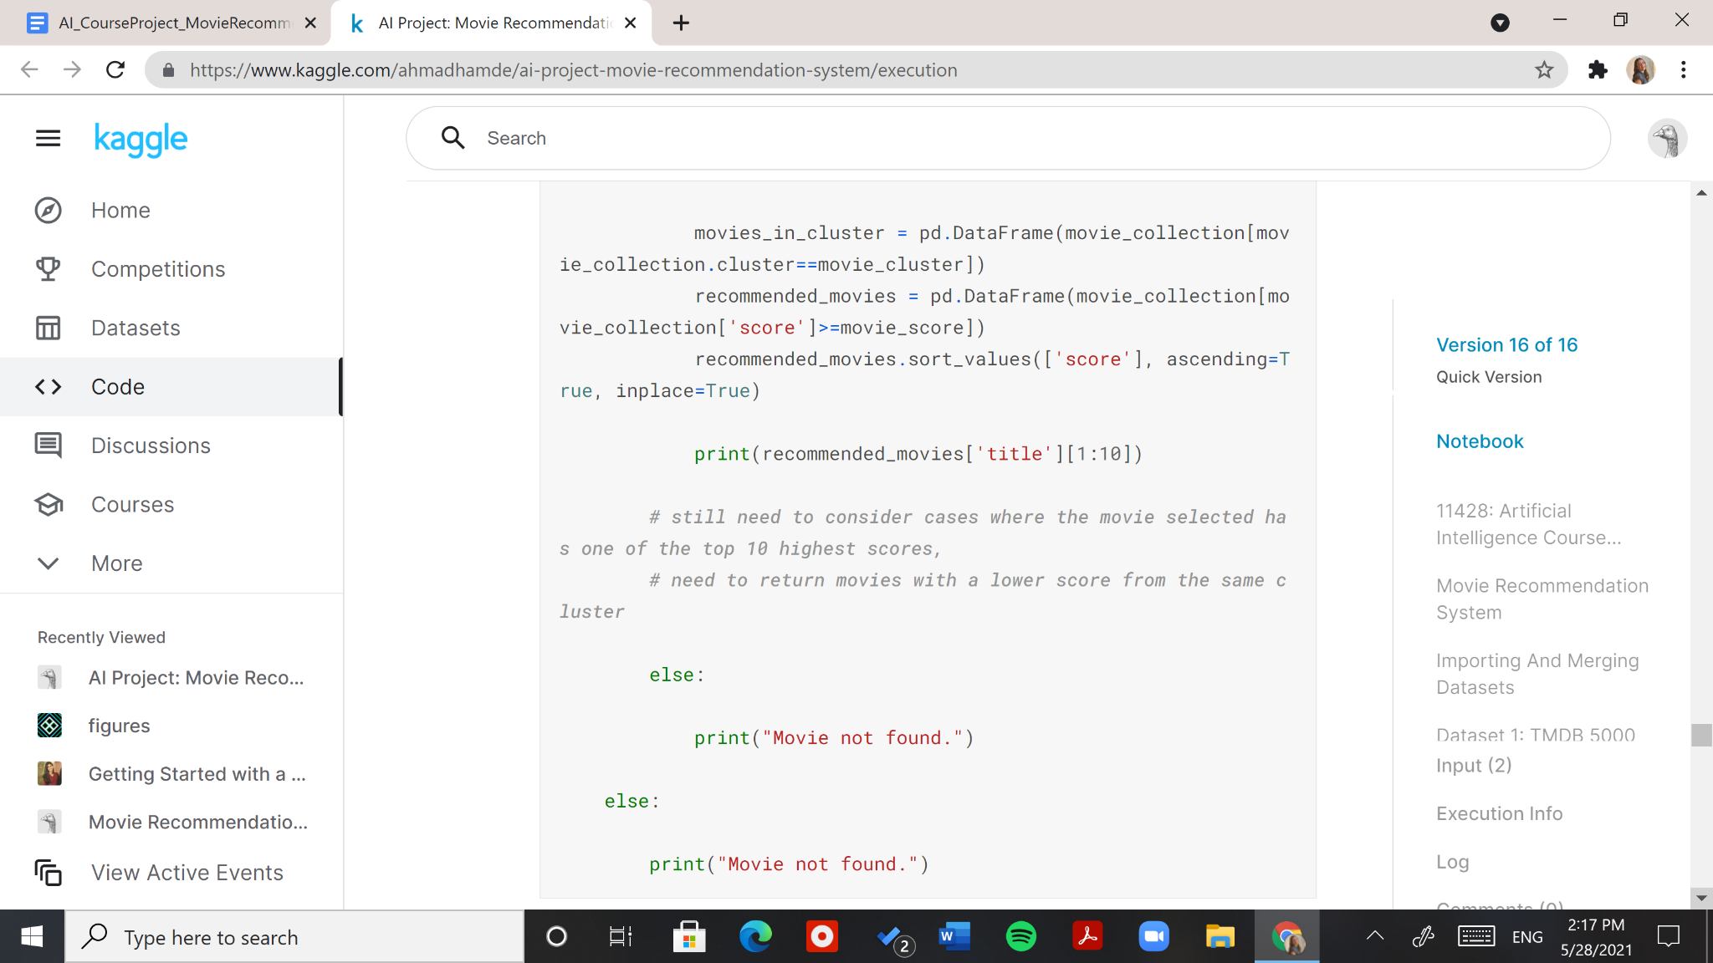



Figure 35: Recommendation Function (Clustering)

We tested our function with three different movies: “Ice Age”, “Alice in Wonderland” and “Toy Story.” Figure 36 below shows the movies recommended for “Ice Age.”



Figure 36: Recommendation Function Output with "Ice Age" as Input

Are you doubting the efficacy of these recommendations too? Don’t worry, these results are why we proceeded with two more approaches for this project. In this output, we personally think only two out of nine movies could qualify as a recommendation, shown in Figure 37 under the “hit” section. The rest of the movies were a “miss.” Our opinion could be subjective as it is based on the movie descriptions and our own interests, but we can all agree that the genres and age groups are not consistent across the movies.

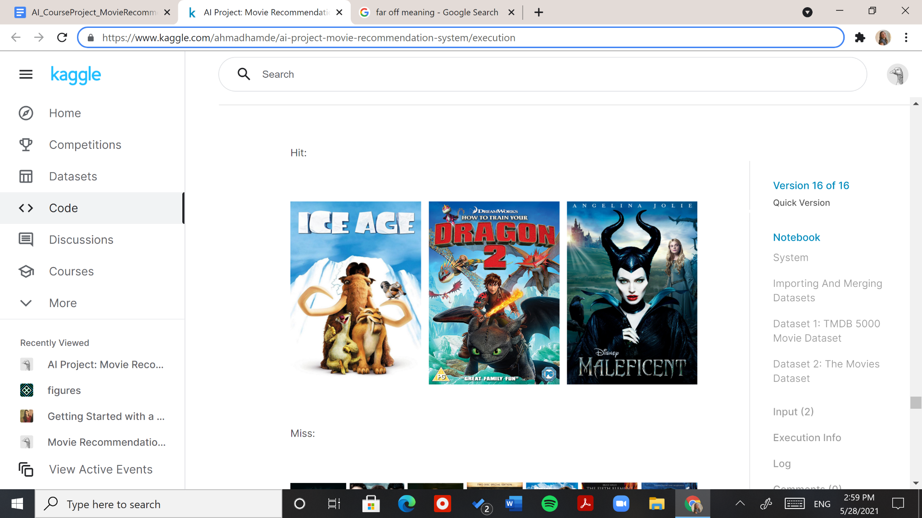

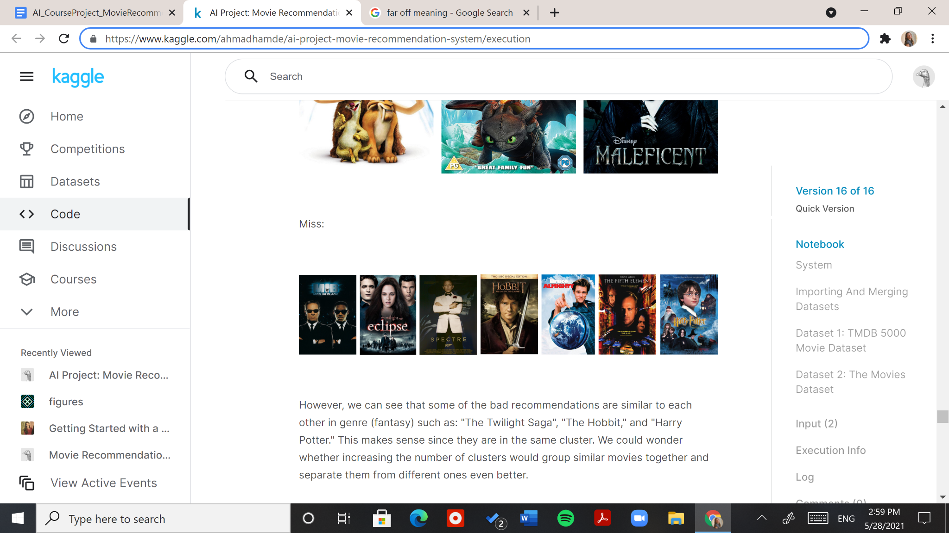

Figure 37: The Hits and Misses of "Ice Age" Recommendations

However, we can see that some of the bad recommendations are similar to each other in genre (fantasy) such as: "The Twilight Saga", "The Hobbit," and "Harry Potter." This makes sense since they are in the same cluster. We could wonder whether increasing the number of clusters would group similar movies together and separate them from different ones even better.

Figure 38 below shows the movies recommended for “Alice in Wonderland.”

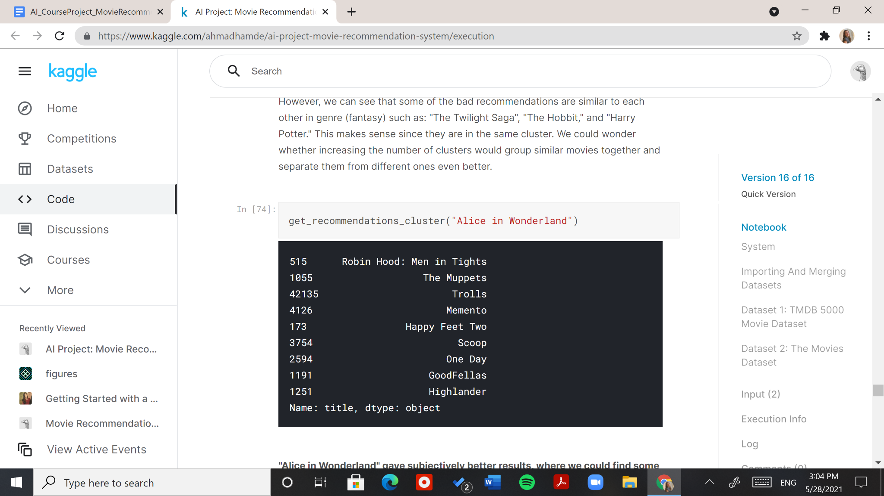

Figure 38: Recommendation Function Output with "Alice in Wonderland" as Input

"Alice in Wonderland" gave subjectively better results, where we could find some connection between our selected movies and four out of the nine recommended movies, shown in Figure 39 under the “hit” section. The rest of the movies were a “miss.”

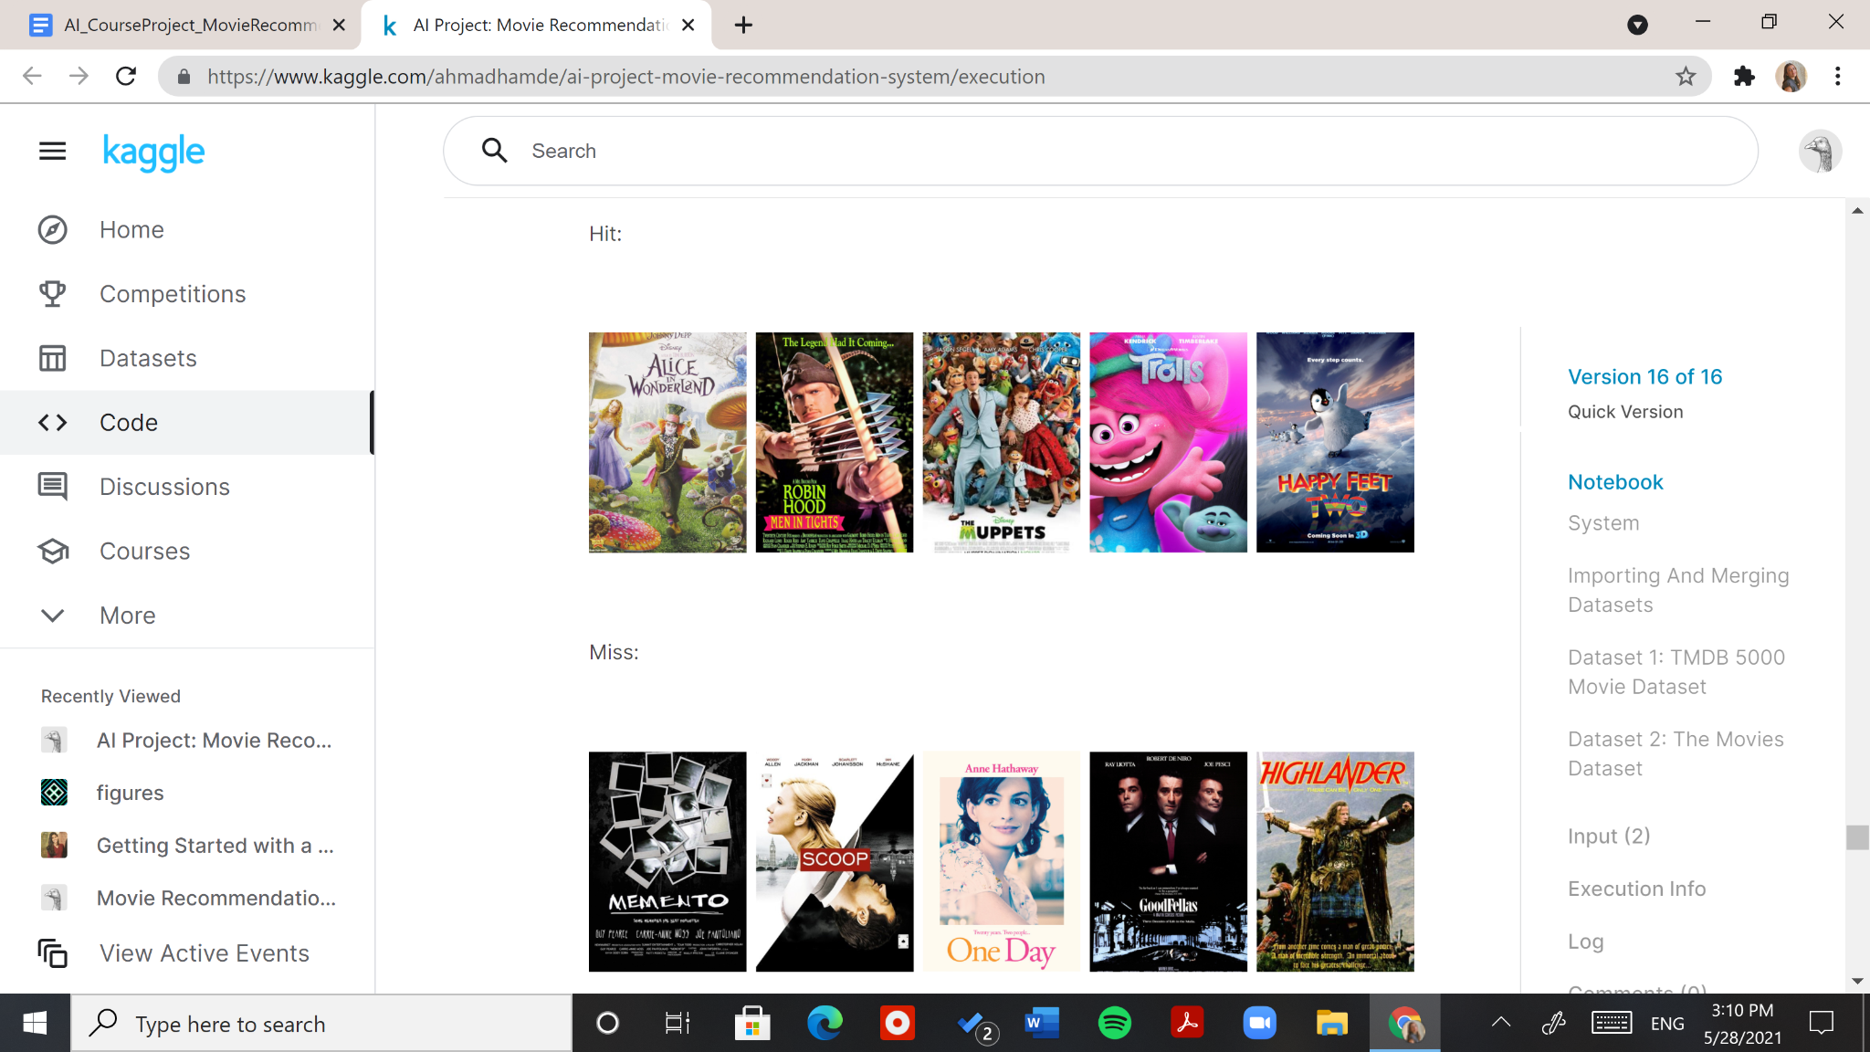

Figure 39: The Hits and Misses of "Alice in Wonderland" Recommendations

The two previous function calls gave 22% and 44% acceptable movie recommendations (according to our point of view after looking at their overviews). Both are very low percentages.

In a previous run for "Toy Story" recommendations, the results included animation movies including but not limited to: "Dragonball Z" and "Three Little Pigs," as shown in Figure 40 below.

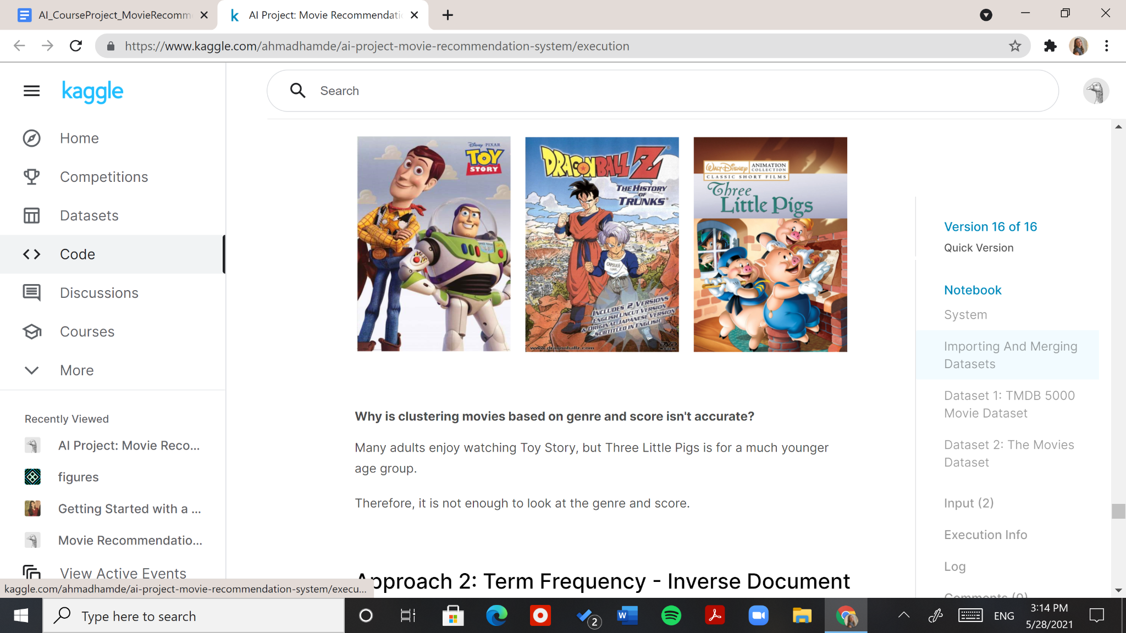

Figure 40: "Toy Story" Recommendations

Why is clustering movies based on genre and score isn't accurate? Many adults enjoy watching “Toy Story”, but “Three Little Pigs” is for a much younger age group. The same applies for “Alice in Wonderland”. It is a Disney movie that is enjoyed by people of different age groups. “Happy Feet Two,” as a recommendation on the other hand, would be a good recommendation when the person who watched “Alice in Wonderland” is a kid. This is where information about users comes in handy in collaborative filtering systems. Therefore, we can conclude that it is not enough to look at the genre and score for our system.

### 3.4.4 Term Frequency - Inverse Document Frequency (TF-IDF) to Recommend Movies Based on Overview

The approach that we went for in our system to improve the results of our first approach is the TF-IDF approach. It uses a word vectorizer to sum up all the words in the overview column of the movie collection dataframe and it creates a vector of all the words included in the overview, removing all the words that have no actual weight like “the” and “a “.

We started by importing the required library for the vectorization from sklearn as shown in figure 15, then we ran the algorithm to extract the relevant words from the overview section and added it to the vector tfidf_matrix.

The constructed matrix is bigger than expected and since we are limited on computing power, a measurement was taken to decrease the word count in order to use less memory as well as make the words more specific, making it more accurate Which was adding a stemmer that removes all words that have the same root and adds the root to a list, the list is then joined and used instead of the original overview string.

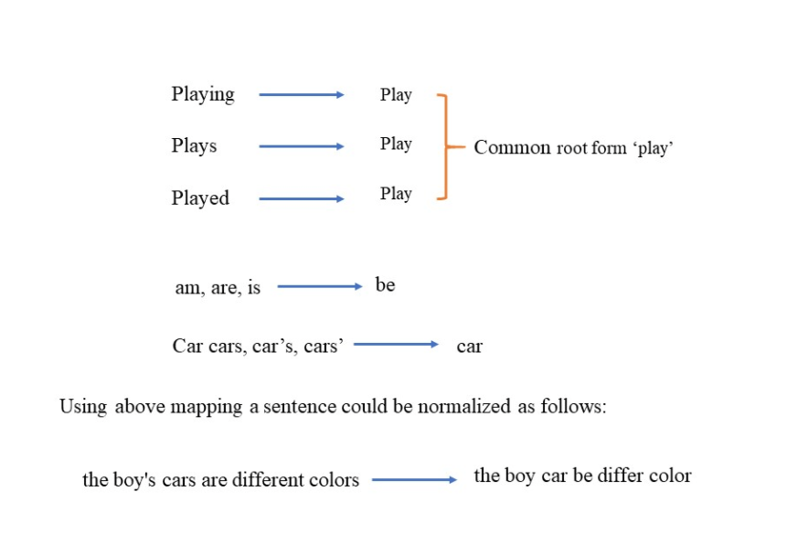

Figure 42 below shows the results of these improvements.

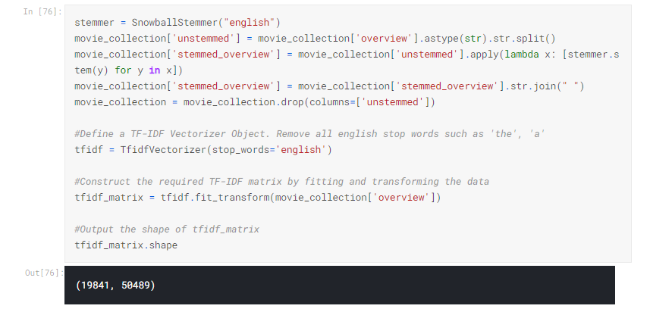

In order to find the similarity between two movie overviews, there are multiple ways to check but since our dataset is huge, we are going for the linear_kernel() that uses a simple dot product equation to find the cosine similarity between every movie with the rest of the movies

We proceed to make a matrix with only the indices and the titles of the movies to refer to it when we want to make the user’s input to its related index so that we can find the similarity between the input and the rest of the movies in the dataset.

Then we implement the most important part which is the get_recommendation function that takes the title of the input movies, returns the index of this movie, then searches the cosine similarity matrix for the similarity between this movie and the rest of the movies in the data set, then we group up and sort the similarities and take the highest 10 to recommend them to the user.

As we can see in figure 43 below, the recommendation is inaccurate as the results don’t show any animated movies that are similar to Toy Story, which means that the word vectorization of the overview by itself is not enough, which brings us to our third and final approach.

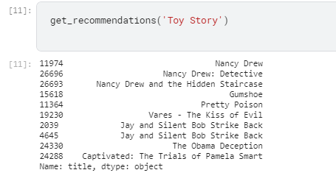

### 3.4.5 Term Frequency to Recommend Movies Based on Cast, Crew, Keywords, and Genres

In the second approach, we based our recommendation only on the overview column. The results were not as promising as we expected because depending on the overview itself showed movies that were not related by genres which was inaccurate. We considered using different data so we went for the keywords, genres, cast and crew columns in our equations. Combining all of them into one string for ease, then we use the count vectorizer to see the count of each word. The difference between count vectorizer and tfidfvectorizer(used in the first approach) is that the latter does an extra step which computes a weight based on its occurrence that can be used for priority, but it is considered time consuming and sometimes can be inaccurate as unrelated words can have bigger weights that the needed ones.

After doing the same process as the tfidfvectorizer but with the count vectorizer, we can see more diverse results that include movies with the same genres, cast and crew as the input movie, all in which are related to the genre of the input movie in comparison to the first two approaches. (figure 44)

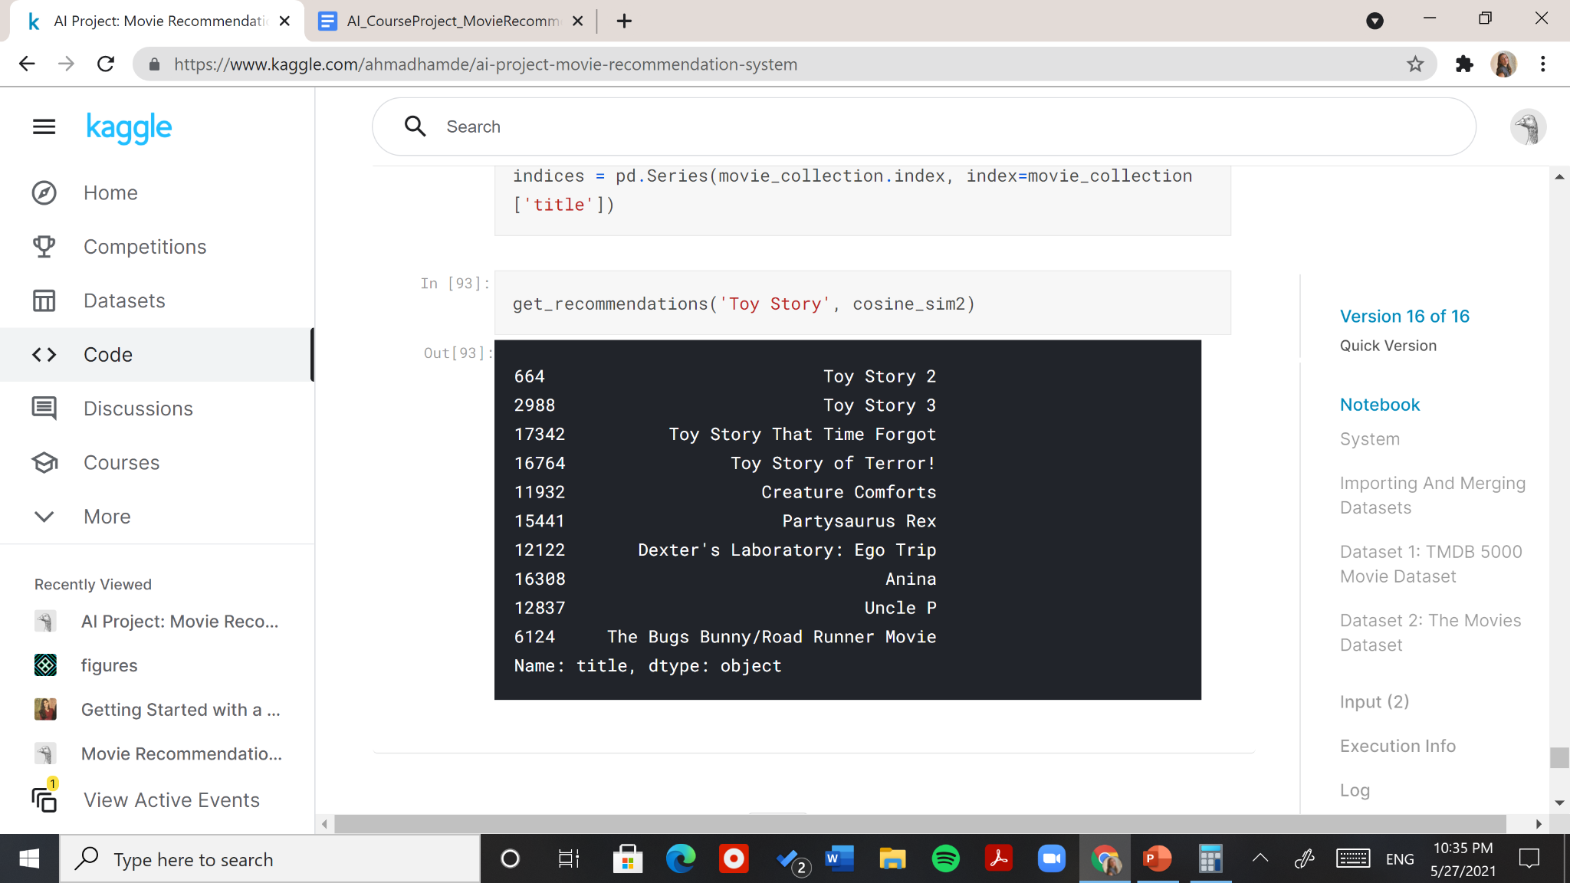

# Chapter 4: Conclusion

All the approaches showed promising results when it came to recommending movies, yet not all of them were inclusive. One of the biggest challenges that all recommendation systems face is that people are diverse and you can’t generalize a specific pattern to all. Some people might love to watch spin offs of movies they liked, others might want to watch movies with different genres but for the same director, making it harder for the recommendation system to be inclusive of all people. Each of our approaches show bias towards a specific type of people, neglecting the rest which is common for recommendation systems. Our third approach showed the most accurate results when it came to recommending movies from a similar genre and cast but it wasn’t enough. A final approach of combining all these approaches together to pinpoint a narrowed down set of movies could be considered further.

This project shed light on the importance of gathering enough information in an approach to give good recommendations, and the depth of recommendation systems. In the future, when we intend to work on a recommendation system, we would consider including user information, as this is what most recommendation systems depend on nowadays, and we can see why. The more we know who we are recommending to, the more outstanding their specific recommendations will get.

# References

[1] (TMDb), The Movie Database. “TMDB 5000 Movie Dataset.” *Kaggle*, 28 Sept. 2017, [www.kaggle.com/tmdb/tmdb-movie-metadata](http://www.kaggle.com/tmdb/tmdb-movie-metadata).

[2] Ahmed, Ibtesam. “Getting Started with a Movie Recommendation System.” *Kaggle*, Kaggle, 16 May 2020, [www.kaggle.com/ibtesama/getting-started-with-a-movie-recommendation-system](http://www.kaggle.com/ibtesama/getting-started-with-a-movie-recommendation-system).

[3] Alahakoon, Nipun, et al. “Output 50 Samples Closest to Each Cluster Center Using Scikit-Learn.k-Means Library.” *Stack Overflow*, 1 July 1963, [stackoverflow.com/questions/26795535/output-50-samples-closest-to-each-cluster-center-using-scikit-learn-k-means-libr](http://stackoverflow.com/questions/26795535/output-50-samples-closest-to-each-cluster-center-using-scikit-learn-k-means-libr).

[4] Banik, Rounak. “The Movies Dataset.” *Kaggle*, 10 Nov. 2017, [www.kaggle.com/rounakbanik/the-movies-dataset](http://www.kaggle.com/rounakbanik/the-movies-dataset).

[5] “Content-Based Filtering | Recommendation Systems | Google Developers.” *Google*, Google, [developers.google.com/machine-learning/recommendation/content-based/basics](http://developers.google.com/machine-learning/recommendation/content-based/basics).

[6] Covington, Paul, et al. “Deep Neural Networks for YouTube Recommendations.” *Proceedings of the 10th ACM Conference on Recommender Systems*, 2016, doi:10.1145/2959100.2959190.

[7] fabs177. “Guilda IA Zup: K-Means Clustering Movies.” *Kaggle*, Kaggle, 12 July 2019, [www.kaggle.com/fabs177/guilda-ia-zup-k-means-clustering-movies](http://www.kaggle.com/fabs177/guilda-ia-zup-k-means-clustering-movies).

[8] Girgin, Samet. “K-Means Clustering Model in 6 Steps with Python.” *Medium*, PursuitData, 26 July 2020, [medium.com/pursuitnotes/k-means-clustering-model-in-6-steps-with-python-35b532cfa8ad](http://medium.com/pursuitnotes/k-means-clustering-model-in-6-steps-with-python-35b532cfa8ad).

[9] Goel, Ankit. “Are You Solving ML Clustering Problems Using K-Means?” *Medium*, Towards Data Science, 19 July 2020, [towardsdatascience.com/are-you-solving-ml-clustering-problems-using-k-means-68fb4efa5469](http://towardsdatascience.com/are-you-solving-ml-clustering-problems-using-k-means-68fb4efa5469).

[10] “How to Boost Sales with a Recommender System.” *Neoteric*, 19 Nov. 2020, [neoteric.eu/blog/how-to-boost-sales-with-a-recommender-system/](http://neoteric.eu/blog/how-to-boost-sales-with-a-recommender-system/).

[11] “IMDb Rating.” *Trailer Hitch*, [trailerpark.weebly.com/imdb-rating.html](http://trailerpark.weebly.com/imdb-rating.html).

[12] Saxena, Shipra. “8 Categorical Data Encoding Techniques to Boost Your Model in Python!” *Analytics Vidhya*, 16 Aug. 2020, [www.analyticsvidhya.com/blog/2020/08/types-of-categorical-data-encoding/](http://www.analyticsvidhya.com/blog/2020/08/types-of-categorical-data-encoding/).

[13] Sublett, Dean. “Beginner's Recommendation Systems with Python.” *Medium*, Towards Data Science, 5 June 2019, [towardsdatascience.com/beginners-recommendation-systems-with-python-ee1b08d2efb6](http://towardsdatascience.com/beginners-recommendation-systems-with-python-ee1b08d2efb6).

[14] “Tf–Idf.” *Wikipedia*, Wikimedia Foundation, 18 May 2021, [en.wikipedia.org/wiki/Tf%E2%80%93idf](http://en.wikipedia.org/wiki/Tf%E2%80%93idf).

[15] Umamaheswaran, Venkatesh. “Comprehending K-Means and KNN Algorithms.” *Medium*, Becoming Human: Artificial Intelligence Magazine, 14 Nov. 2018, [becominghuman.ai/comprehending-k-means-and-knn-algorithms-c791be90883d](http://becominghuman.ai/comprehending-k-means-and-knn-algorithms-c791be90883d).

[16] “What Is TF-IDF?” *MonkeyLearn Blog*, 10 May 2019, [monkeylearn.com/blog/what-is-tf-idf/#:~:text=TF%2DIDF%20is%20a%20statistical,across%20a%20set%20of%20documents](http://monkeylearn.com/blog/what-is-tf-idf/#:~:text=TF%2DIDF%20is%20a%20statistical,across%20a%20set%20of%20documents).

1. Content-based filtering: uses features relating to an item a user interacted with previously, to recommend similar items. It is different from collaborative-based filtering which recommends items based on similar user behavior.
2. <https://www.kaggle.com/ibtesama/getting-started-with-a-movie-recommendation-system>
3. <https://towardsdatascience.com/how-do-netflix-and-amazon-know-what-i-want-852c480b67ac>
4. <https://medium.com/analytics-vidhya/featurization-of-text-data-bow-tf-idf-avgw2v-tfidf-weighted-w2v-7a6c62e8b097>
5. <https://www.kaggle.com/tmdb/tmdb-movie-metadata>
6. <https://www.kaggle.com/rounakbanik/the-movies-dataset>
7. <http://trailerpark.weebly.com/imdb-rating.html>